user interface

# visual design

## initial ideas

The core features that the UI will need to include are:

🡺 Text areas for both code entry and for the output to appear  
🡺 Ability for inputs to be taken in, ideally in the same window as output  
🡺 A run button which will execute the contents of the code  
🡺 A title and menu with links to different resources such as documentation and examples  
🡺 An ability to upload and download different ERL files to be ran  
🡺 Being able to upload and download text files so that the program can interact with them  
🡺 Allowing the text files to be modified in the interface and reset to their original contents.

### paper drafts

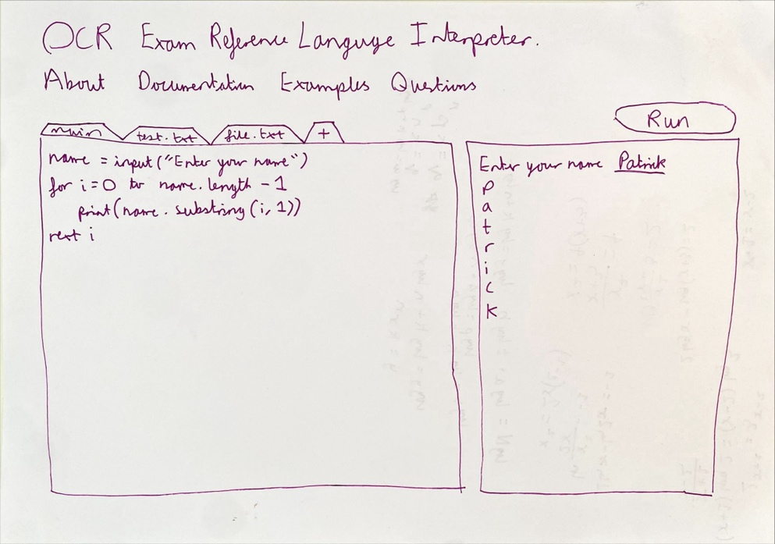My initial interface idea is on the left. I like a lot of aspects of this: having the large windows for code entry and output, and the tabs for different files.

However, I still feel more of the window could be taken up by the windows: as it is the focus of the interface and I do not want to detract from it.

I’d also like buttons for uploading and downloading the code written, so a few extra buttons will be needed, and the different files could probably take up less space as they won’t be used that frequently.

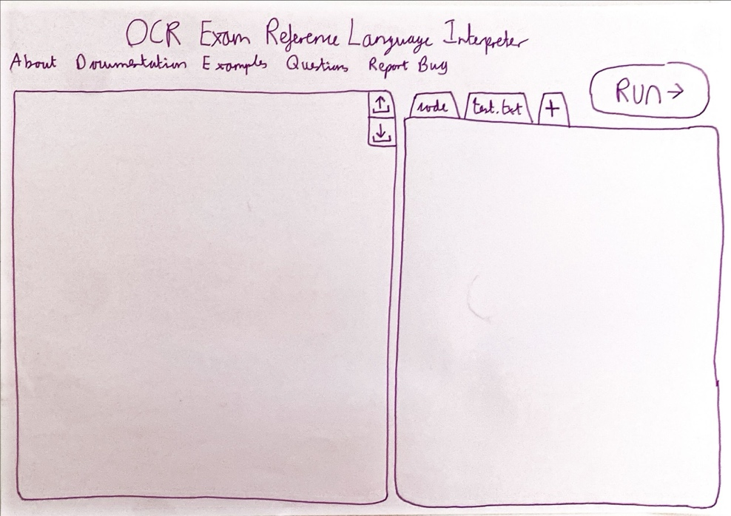The second version improves on these issues, with much larger windows, including an upload and download button in the top right corner of the input window.

The file system has now been moved over to the output side, as I feel like it is more useful to be able to view the sourcecode and file contents at the same time.

When showing Tanish this design, he agreed it would be good, but specified that hovering over different aspects should explain more clearly their functionality in case some users find the upload or download or file add buttons confusing, which I will do.

## html mock up

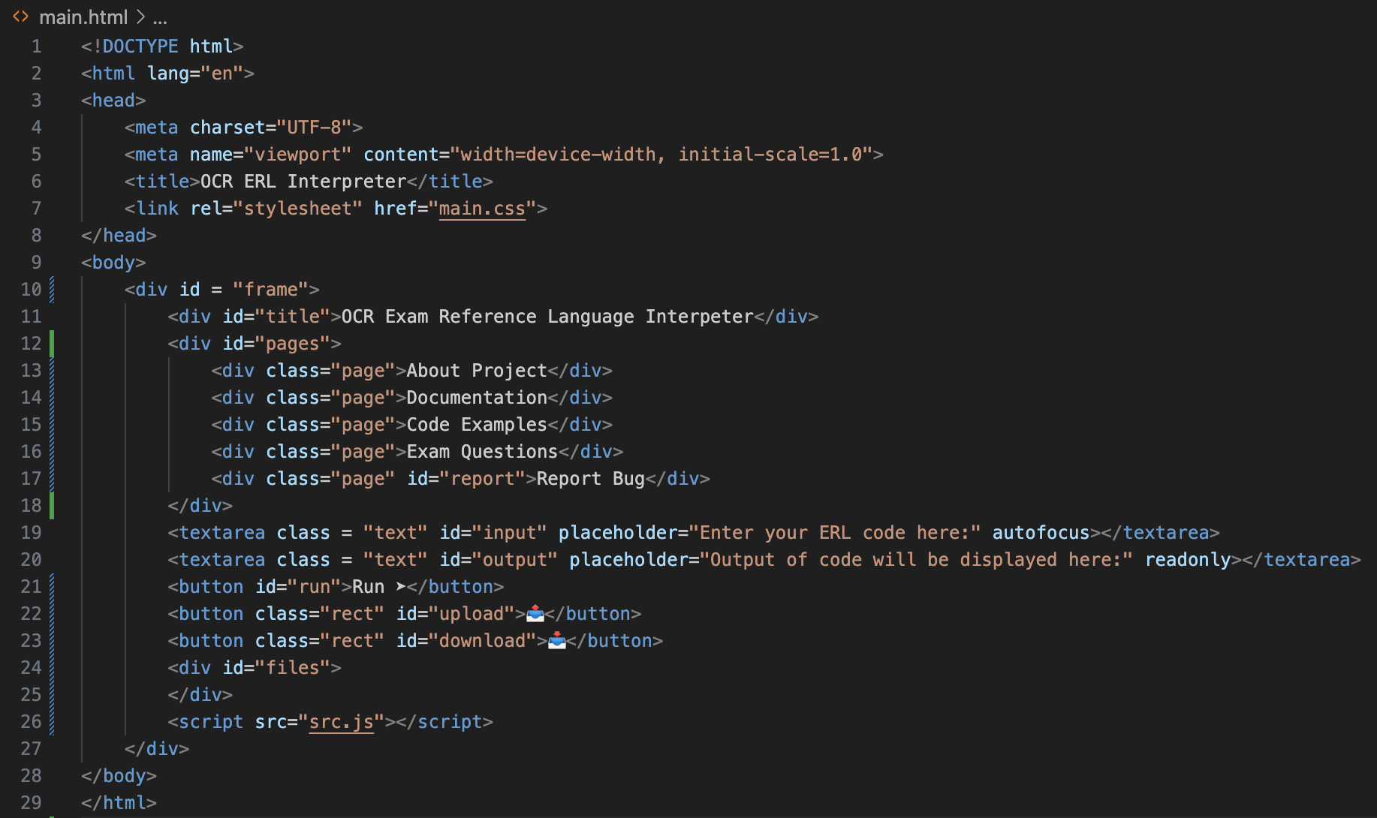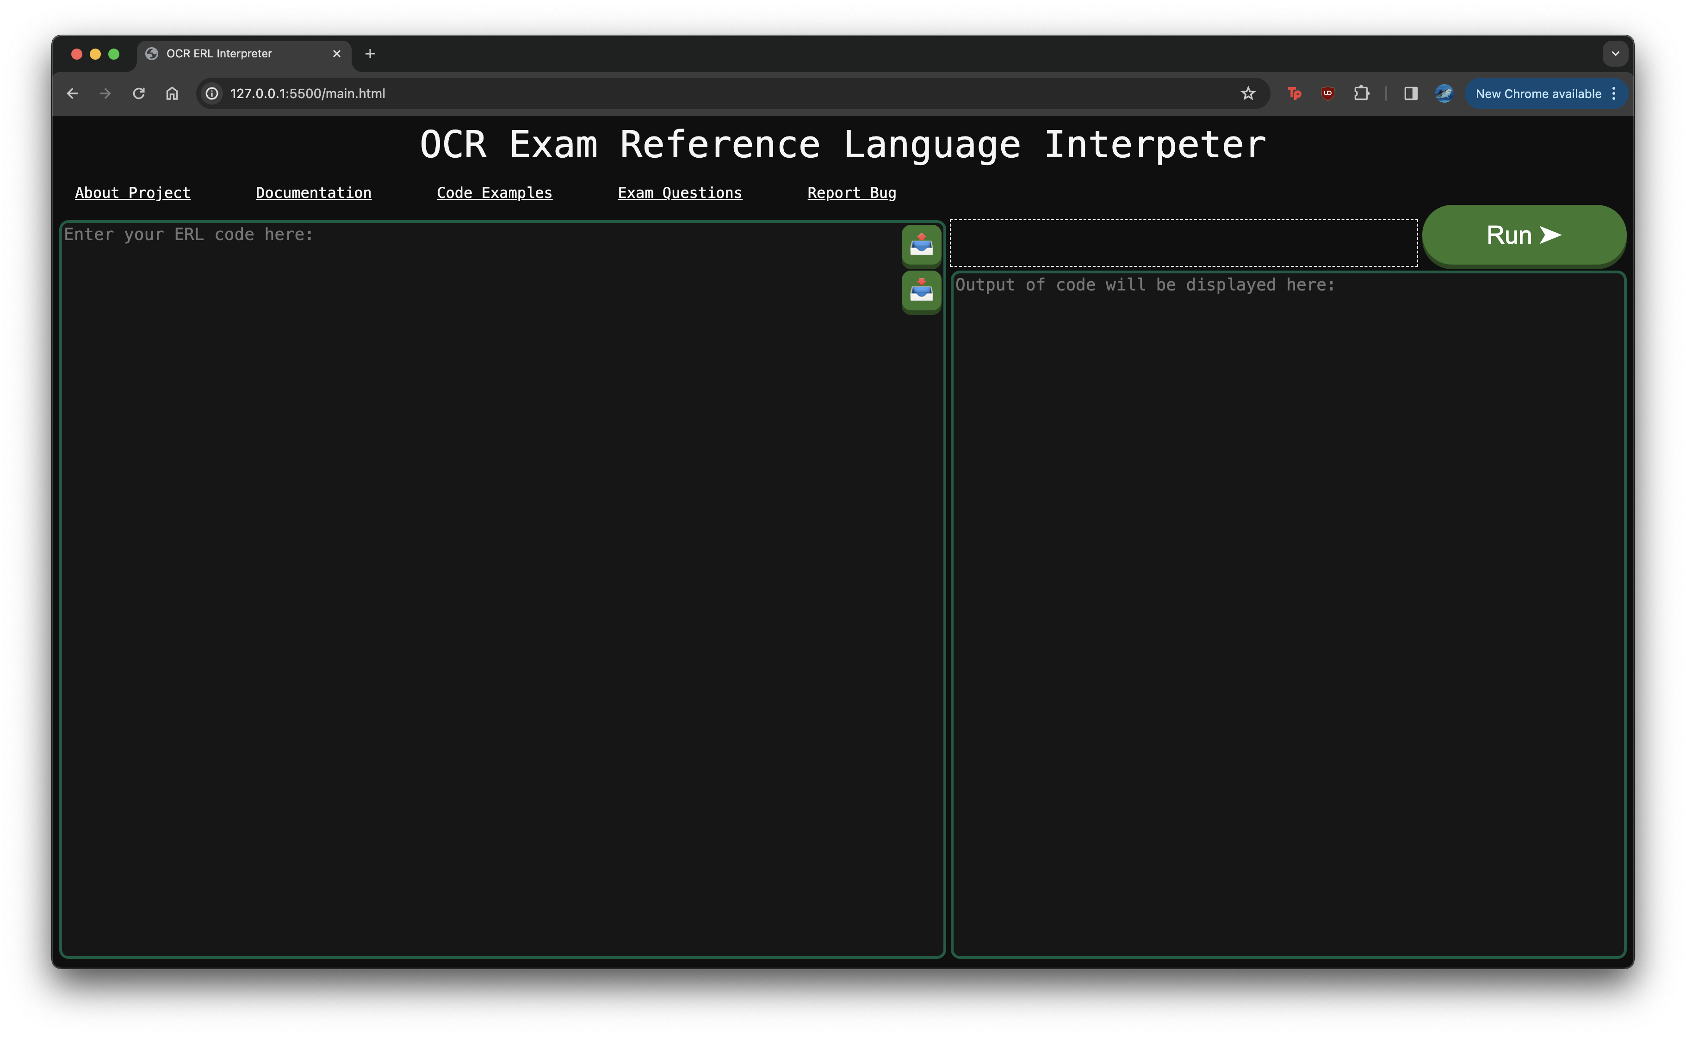I mocked up this design in HTML and CSS. Overall, the layout is very simple: using a large grid of 30x20 to align all of the different sections correctly. I am generally happy with the format and have based all of the dimensions off the screen dimensions, so that it should scale correctly for most computer screens.

The basic HTML is shown on the left, with the most important aspects being the IDs for the different sections, primarily “input”, “output” and “run”, as we will need to use these with JavaScript to interact with the interface.

Currently, the white dotted border is where the tabs for file handling will go, however I am going to implement that after the rest of the system is correctly working as it is less important.

I also included a lot of CSS styling to correctly format everything, which I will not show because it contains no useful code. From here, I need to link up the interface with the actual code.

# linking in the interface

For helping development, I am going to use jQuery to link the code in more easily with the interface. Everything can still be done in vanilla JavaScript, but it saves a lot of additional, confusing code so I will use it. Additionally, there are differences in how different web browsers render websites, and they have slightly different syntaxes. jQuery will ensure that my site can render on more web browsers, so that it will be available to more students. The first example of this is printing.

## printing

The $() jQuery syntax is the equivalent of document.getElementById() in normal JS. Therefore, the string inside is the equivalent of accessing the document with that ID. Therefore, this means that:

$(“#input”) 🡺 The input textarea  
$(“#output”) 🡺 The output textarea  
$(“#run”) 🡺 The run button

Some additional syntax which is important to know is:

🡺 $(“#run”).click( function )  
This will execute the function whenever the run button is clicked.

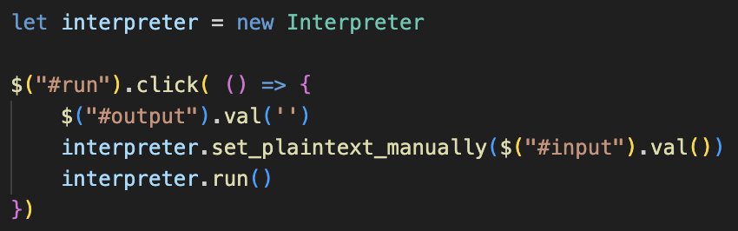🡺 $(“#output”).val()  
This will return the current contents of the output textarea. Additionally, passing an argument will then set the contents of the textarea to the value passed.

So, the code on the left checks when the run button is clicked and will clear the output field, set the interpreter’s plaintext to the current contents of the input field, and then will call the run() method.

This is what is needed to run the code.

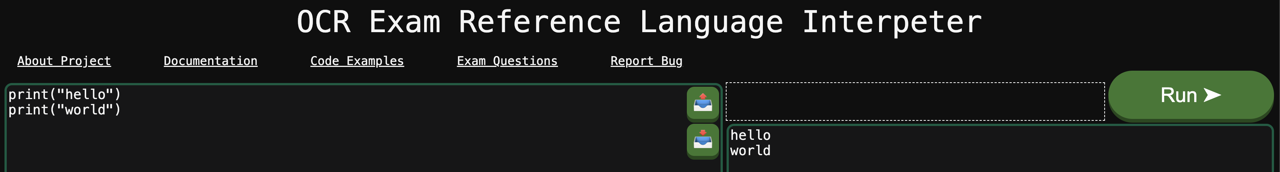Furthermore, outputting values is also very simple. Instead of calling console.log(), it will update the value of the output field with the value to be printed, and this will display the output.

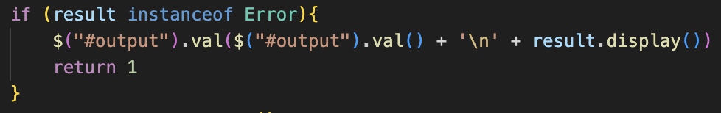Running a small test shows how this works:  
I also added the code so that any error messages are also displayed, completing the outputs so now I can move onto the more complicated counterpart: inputs.

## inputs

Trying to implement inputs took significantly longer than expected, and I have removed a lot of write-ups about it because there were so many errors, however I will summarise the issues here.

JavaScript is a synchronous programming language, so by default, it will not wait for a function to complete when it is running. This leads to huge issues when trying to use inputs, as even when just using the default prompt(), the program would run the lines after the input() before waiting for the value to be entered, which would break the entire sequence of the program.

This should have been an issue originally, but the prompt module I used for node somehow managed to deal with this issue, but when converting to no longer using it, some large changes need to be made to the program to stop this skipping ahead.

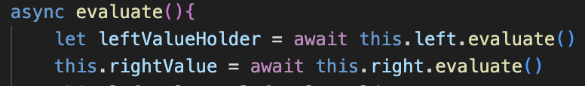The solution to this is using the JS async and await keywords, which make a method asynchronous. Therefore, whenever await is place before a function call, it will not continue executing that method until the value is returned.

The example for how this works for the BinaryOperator class is shown on the left, waiting for the two evaluates() to complete.

For the system to correctly wait for inputs, every single method that calls evaluate() on another method or calls a method that will then call evaluate() on something else will need to also become asynchronous and will have to wait for its competition.

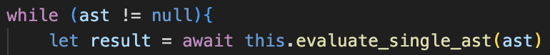Typically, this would have been done throughout development, but this means that these keywords must lots of methods throughout the entire program. More specifically, whenever evaluate() or call() or set() are used, as this is when the program must wait.

This starts from run() in the Interpreter, waiting for each iteration.

From here this continues up, into all the Evaluator methods and practically every single class excluding the Lexer and Parser – as these are not affected by inputs so are not required to wait. I cannot show all of the changes as it affected the whole document, but it should be complete, however I will need to do some testing to ensure that I have not missed any as it could break the program.

### basic text entry

Because I do not want pop-up windows, I need a way to enter inputs into the output textarea.

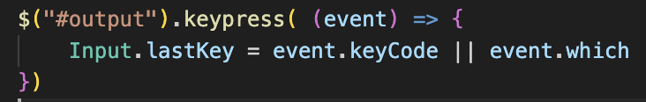On the jQuery documentation, I found this code to detect a keypress in a textarea, which was at the following link: <https://api.jquery.com/keypress/>

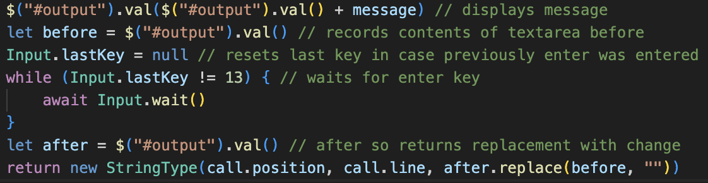The code will now detect any keypress in the textarea and will set a new static property in Input called lastKey to the code of the input.

The code displays the messaged and records the contents of the text area before the input. Then it will wait for the key code 13, which is the key code for the enter key.

Then, it will record the contents afterwards, and will return the change in the textarea as a StringType.

### Waiting

The reason for the wait loop is that we need to pause the program from continuing until the enter key press is entered, as execution cannot continue until this occurs.

Originally, I tried placing nothing inside the while loop, however this crashed the program at the rate that it was executing, so I had to find a solution that would wait a certain amount of time. For this, I was researching on the internet and found the following post:

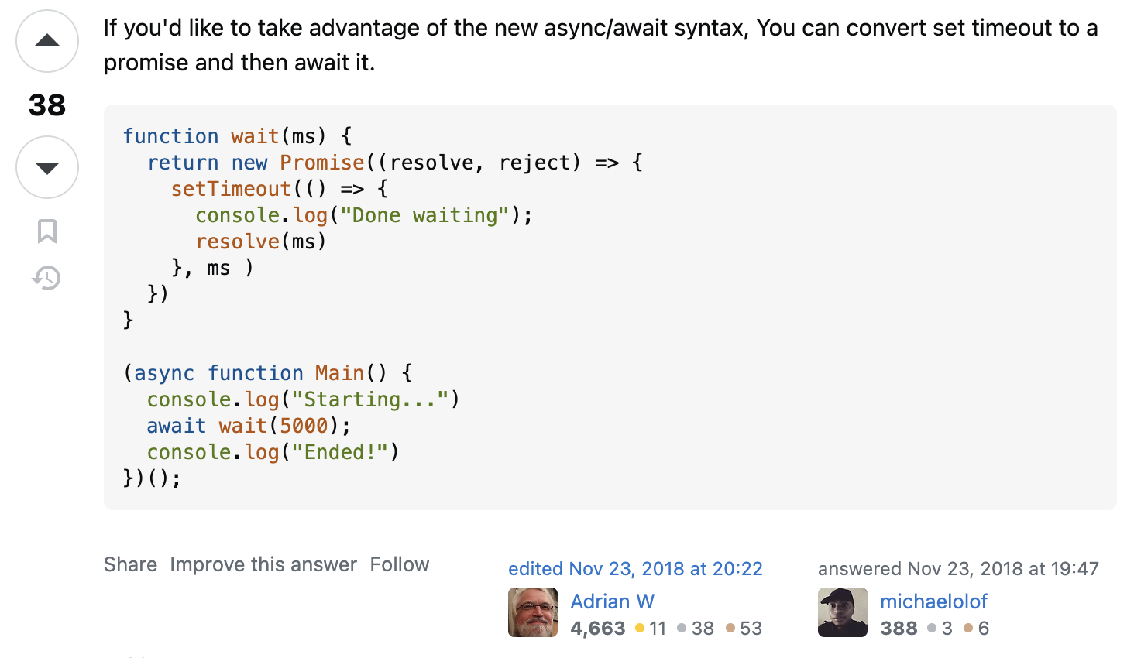<https://stackoverflow.com/questions/6921895/synchronous-delay-in-code-execution>

More specifically, it is this code on the left which shows a method using a Promise which will wait a certain number of milliseconds before returning itself.

Therefore, if the method calling it is asynchronous and uses await when calling this method, then it will pause execution.

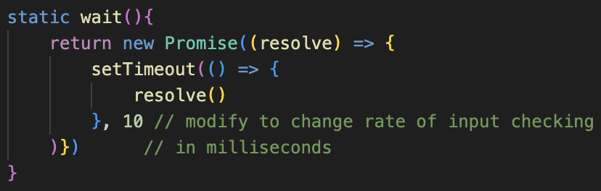Therefore, I am using this to wait a small amount of time before checking again, which will stop JavaScript crashing by running the while loop excessively.

My adaptation of this is Input’s wait() static method, which will just wait 10 milliseconds before returning. I feel this is a suitable length, as checking 100 times per second for inputs should be enough, however I can easily modify this to check more or less often if needed.

### testing and changes

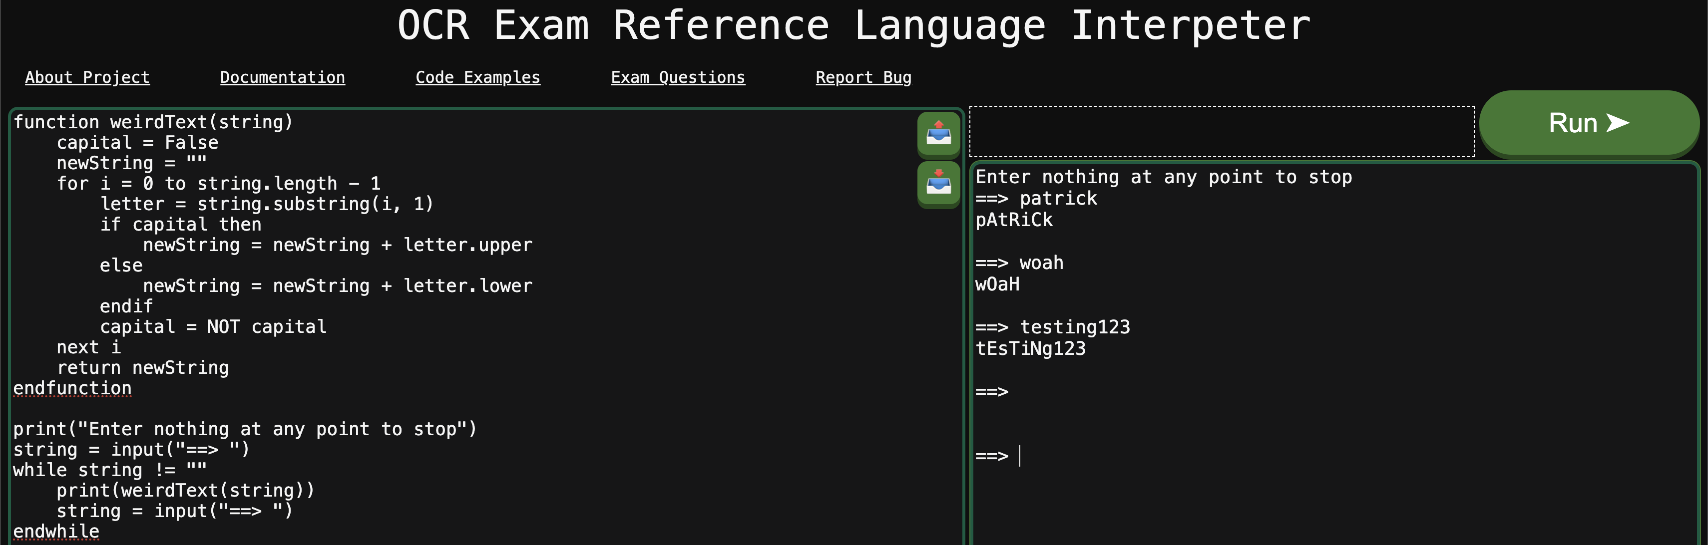When running a larger test case, this was the result:

This was overall very successful but had a few issues. Inputted strings seemed to have the \n stored at the end of them, which needs to be removed. Additionally, some sort of final message will be needed to clearly display when the program has finished running.

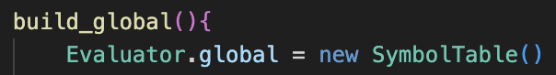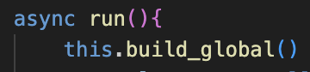For the inputs, I remove the last character from the string, which will remove the newline so now the string will only contain the actual input without the newline. I also have change run() to reset the symbol table every time the program is run, so that the variables do not exist between different instances. However, I am keeping the files as I feel they should not be deleted as they are more permanent.

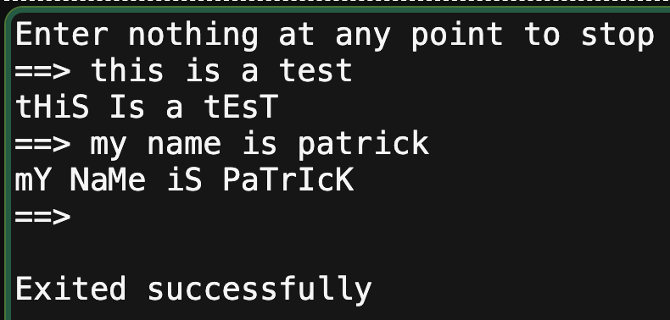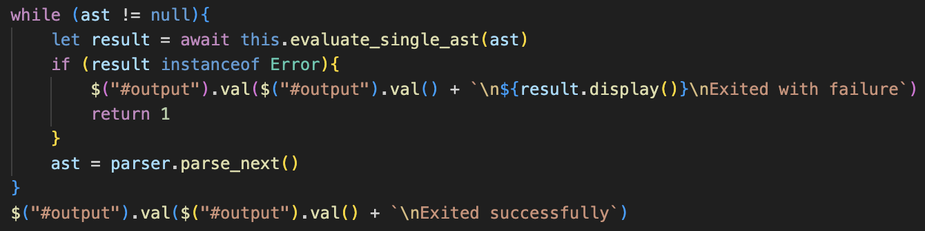Finally, run() will now display “Exited with failure” or “Exited successfully” as the program halts, to properly distinguish whether the program was a success or not.

Now the program correctly outputs the messages, alongside displaying the final message when the program is complete, and the test case is a success.

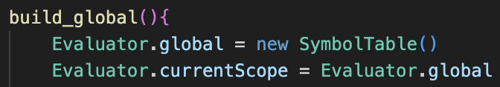I also tried to run my binary conversion code, which had further issues with async with I had to fix which will probably become a concurring theme and will need to be changed.

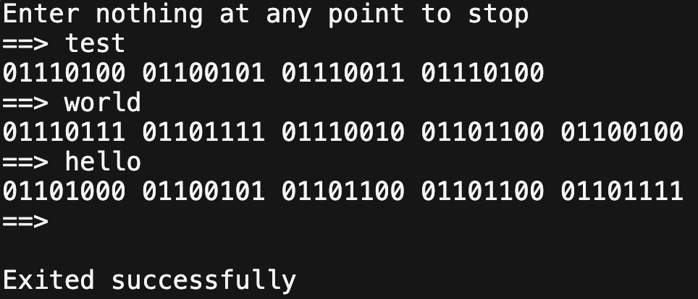I also needed to update the currentScope when resetting the symbol table, as otherwise the scopes break.

After those fixes, that algorithm also works correctly. Both of the different algorithms use a lot of features, so hopefully a lot of the async issues should be fixed due to the large amount of time I spent debugging them both.

Now I need to refine the Input system to ensure that it cannot be broken with incorrect usage.

## srtict input validation

Currently, when entering an input, the entire contents of the output can just be deleted and modified, which is not good and we want to avoid. Therefore, we need to ensure that the text can only be changed when an input is needed, and that the cursor does not move from where the input is entered.

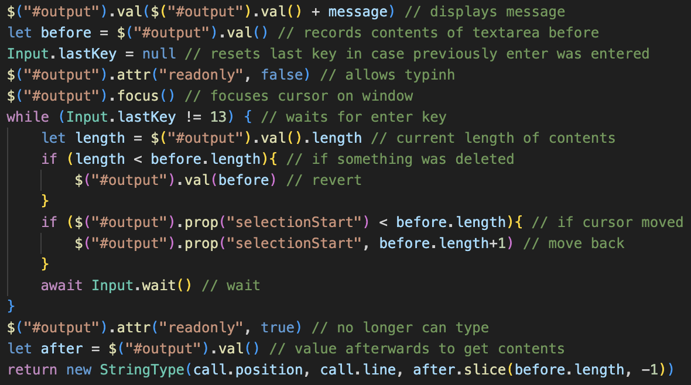The code on the left is the upgrades. Now, when the program is ready for an input, the readonly attribute of the area will be set to false so that it can be edited, and it will be focused so that it is ready for an input and does not have to be clicked on. The readonly attribute will now be set to true by default.

Then, during the loop, it will continually check the length of the textarea’s contents. If it is has decreased, then the contents will be reset to the initial value. This does not affect deleting any characters in the input, and only if they attempt to remove the original contents.

The other check is for the cursor position, and if it is before the area of the input, it will be moved back to the start of the input. Therefore, they will only be able to select the area that is intended, creating the illusion that it is the only area that can be edited.

Finally, after it is complete, it will set readonly to true again, so that it can no longer be edited, and then the corresponding string is returned, using just slice() now instead of replace(), because it should be faster as we already have access to the length before.

### testing

It is hard to show proof here, but the system did work. It is not perfect, as technically when clicking elsewhere it does appear for a split second and then vanish, but that doesn’t matter and does not affect the system. Additionally, the last character of the input message can be replaced if the user spams the left arrow key and a button really quickly and if trying long enough, however this cannot be done on accident and would not cause much of an issue so it does not concern me, and additional checks may slow down the code, and I want to keep them as brief and unobtrusive as possible.

Therefore, this section is a success as now there can be no accidental deletions of the code, and it should not affect an actual user who is using the program intentionally. Plus, any impacts are at most a one-character visual change, which does not change the functionality so is not an issue,

### button spamming

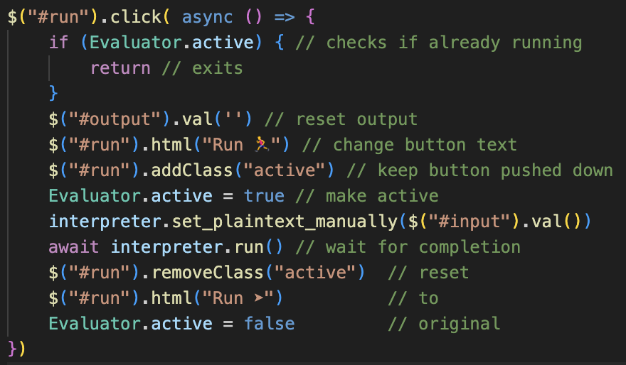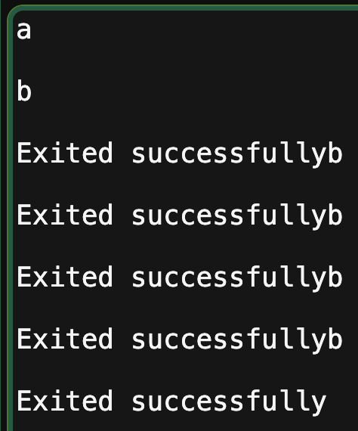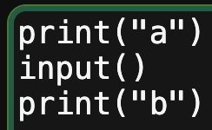Currently, if the run button is clicked lots of times when a program is running, such as during an input(), then it will overlap lots of instances at once which will result in some very weird results which we need to avoid.

My solution is adding a new static property to Evaluator called active. This will represent whether the program is currently running.

It will be set to true whenever run is pressed and set to false when it is complete. If it is already active when the button is first clicked, then it will immediately return and nothing will happen.

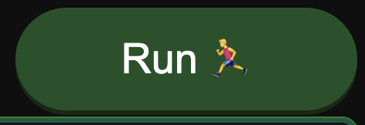The other aspects are to change the visual looks of the run button: the active class will map to the same CSS styling as when the button is pushed down, so it will look like the button is held down when the program is running, to make it seem like it cannot be pressed again, as well as adding a small text change.

During testing, this was a success as now repeating the same test of spamming the button had no impact on the output as they would be ignored, and the button visually stayed held down which made it clear to a user.

# uploading and downloading files

Now I need to implement the upload and download buttons, as currently students will lose their code whenever they leave a website, so being able to store local copies will be very useful for working on the same code at separate times, as well as potentially allowing teachers to distribute work to a class by sending them all a file which they can use.

Previously I have used the .erl file extension for my files, but when checking this has been taken by Erlang files already, so I am going to use .erlcode, which Tanish suggested, and will most likely be clearer to the students for the purpose when they see it saved locally. Plain text files should also be acceptable for upload and should still be read and correctly added.

## uploading

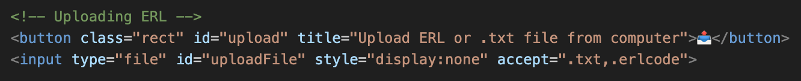When researching, in order to allow files to be uploaded, you need a input with type file, which I have now added but I have hidden so that it will not be rendered.

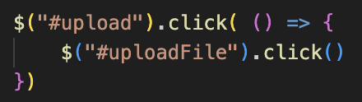Instead, clicking my custom upload button will click the hidden file upload, so that my interface can be kept without the huge “Upload file” button being present, which I could not hide when I tried.

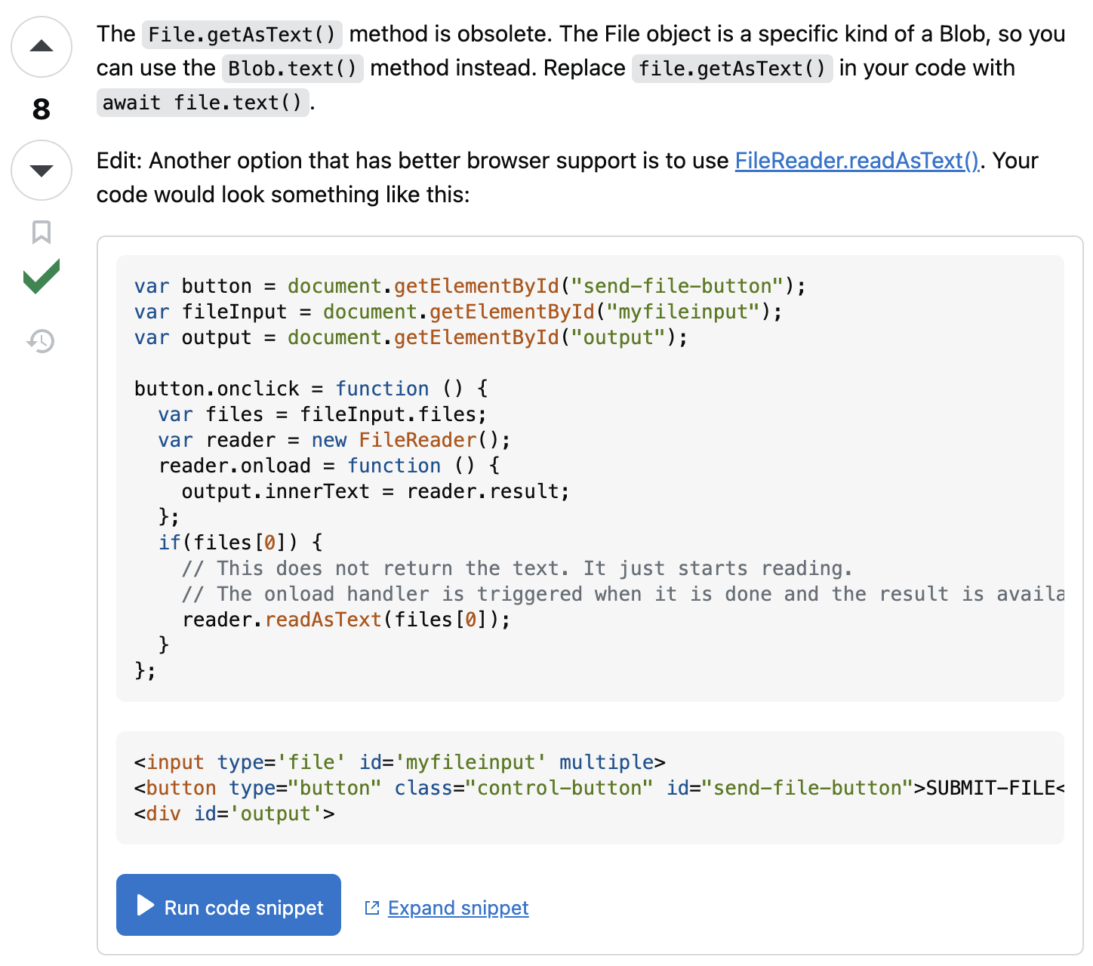In order for the input to actually function, I found the following resource online:  
<https://stackoverflow.com/questions/60532747/converting-file-input-to-text-in-javascript>

It was this post on the left which I used to find the code for this to work, as it was the simplest out of the methods I could find.

I adapted it to my specific solution by changing it from a submit button to when a file was uploaded to the input, so that it would automatically pass the code, and so that the contents would be written onto the input text automatically.

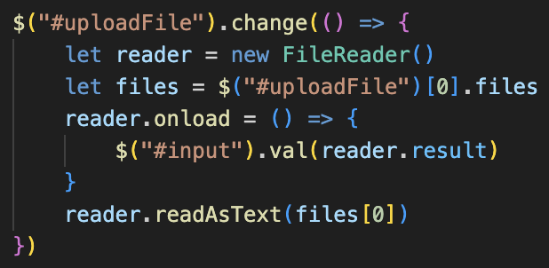I also adapted it to use jQuery so that it would work across more platforms. My version is here:

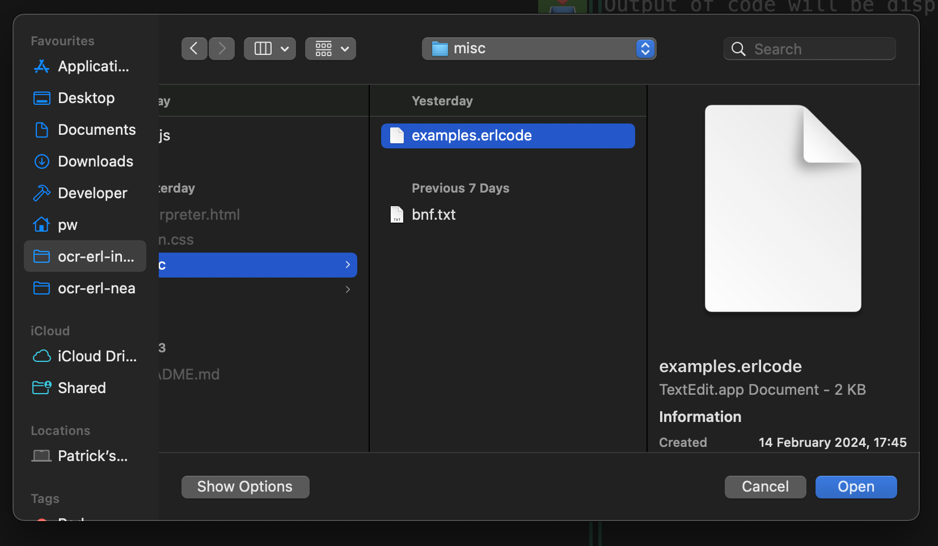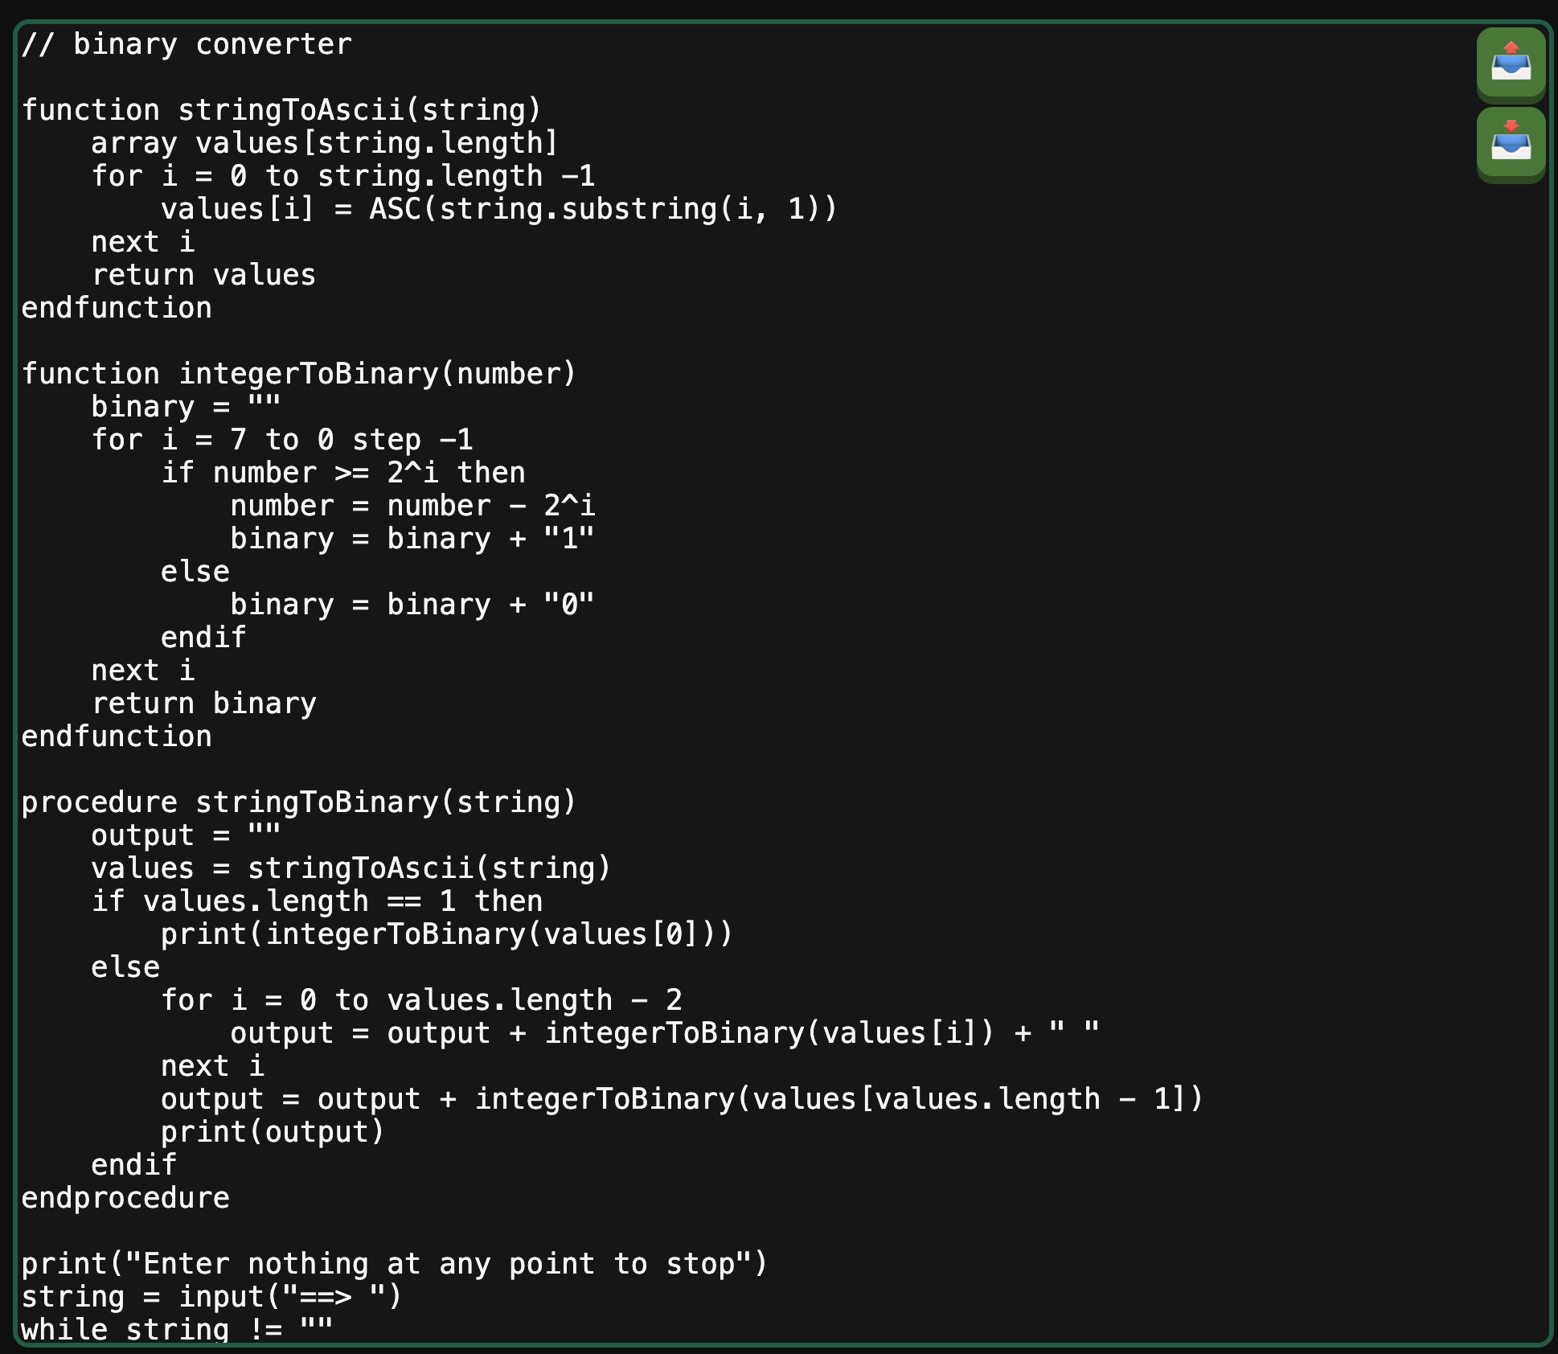  
Now, whenever the upload button is pressed, it will prompt the file upload to automatically open, only showing text files and .erlcode files due to the accept tag in the html.

Then, when one is opened, it is automatically pasted into the input, as shown on the left.

This is exactly the implementation that I want, as it makes it extremely easy for users to upload files they have, so now I just need a way for files to be downloaded.

## downloading

I wanted downloads to always produce a .erlcode file for consistency, and the download button should automatically put the contents of the input into a file and automatically download it. I also would like a way to name the files without a prompt popping up, so I would like to check if the first line is a comment, and if it is then I will name the file download based on the contents of the comment.

That would be an easy way to title the files, and I have chosen the default name to be “myCode.erlcode” as it seems like a very basic and clear name if the file is not given a proper name.

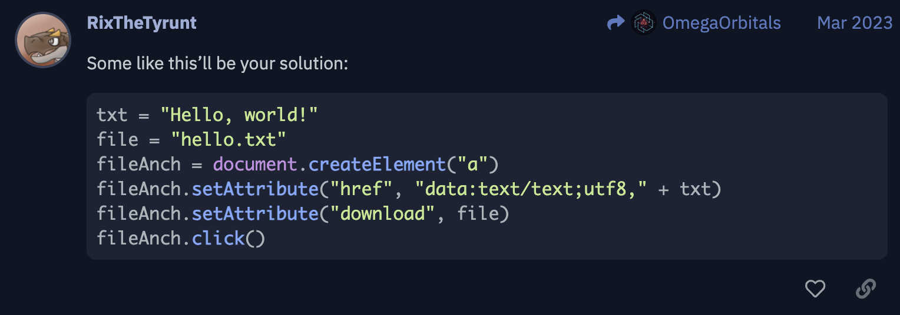When finding a way to allow for custom file downloads, I found the following resource:  
<https://ask.replit.com/t/create-file-from-input-and-download-it/17159>

This allowed for me to use custom naming for the file, as well as customising the contents in a very simple format.

Again, this required an anchor tag, which I added to my HTML and hid like the file input, so that I could use my custom buttons.

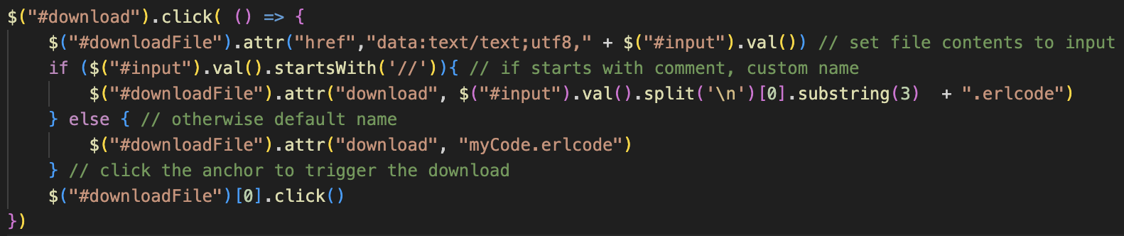By default, the file name will be my default “myCode.erlcode”, and the contents will be the empty text file, however I will update these whenever the download button is pressed.

Whenever the download button is clicked, the attributes will be changed to their corresponding values and it will click the anchor, triggering the download.

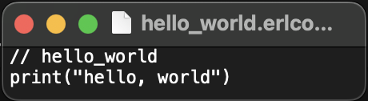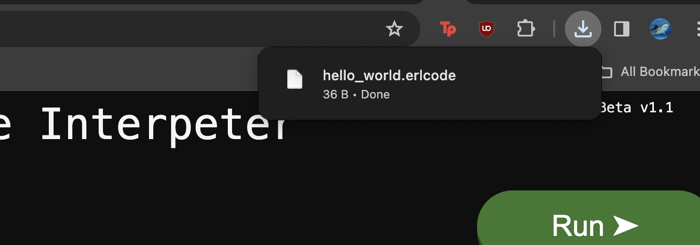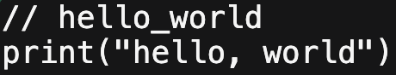Overall, it is very simple, just setting the href attribute to the file string, which was used in the resource, followed by the contents of the input, and the filename is also very easy to implement.

Now, as shown, pressing download will create the file with the correct name, based on the initial comment, and when opening it locally in a text editor, the correct contents is shown.

## final additions

Before moving on to the file management, there are a few more tweaks I need to add which would improve the overall experience.

### tabs

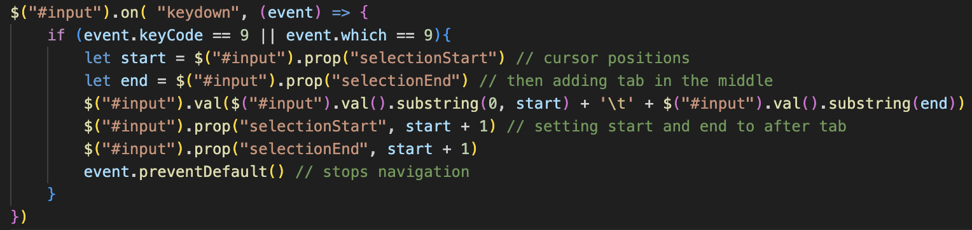Currently, when pressing the tab key on a keyboard, it navigates the webpage and moves between different windows. Instead, I would like it to indent the code, so that different layers can be made in the ERL to make it more visual, rather than a completely flat file, and entering spaces is painful.

I am adapting my code for checking for the enter key, but this time using “keydown” and checking for code 9, which is the code for tabs when googling.

After that, it is very simple: inserting the tab character at the position where the cursor is, and accounting for the case where it is selecting lots of text and replaces it all with a single tab. Afterwards, it moves the cursor to the position after the tab, as expected. preventDefault() stops the navigation between windows.

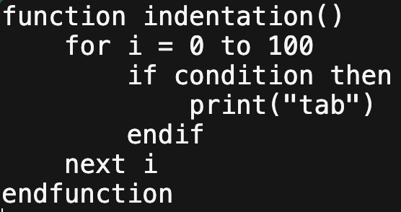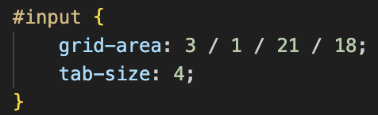I also changed the default tab size of the input window to be 4 characters, so the indentation would not be huge, and now it will be a lot more of a manageable size to be more easily read.

An example of this is shown on the left, and the code is a lot more readable than the completely flat equivalent.

I also changed the Input system to be consistent with this.

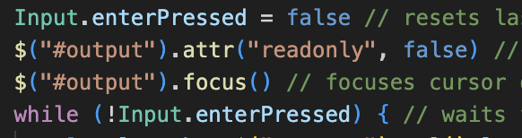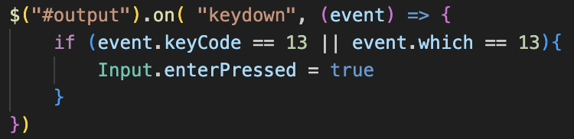Instead of checking for the keycode in the Input call() method, I now check for it in the event listener, and only set Input’s enterPresed property to true when it is done. Therefore, I can just check if enter had been pressed in the main loop, which is a lot easier to understand and maintain.

### exited messages

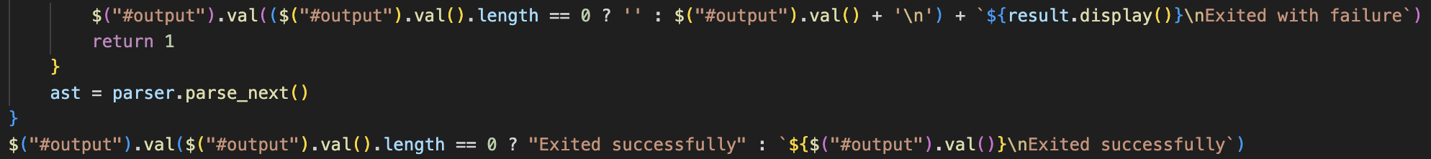I also updated the error messages, so that if nothing had yet been outputted, there would not be an empty line before the error message, and it would just appear at the top as it looks a lot better.

### A black background with white text Description automatically generatedwhile true and stopping

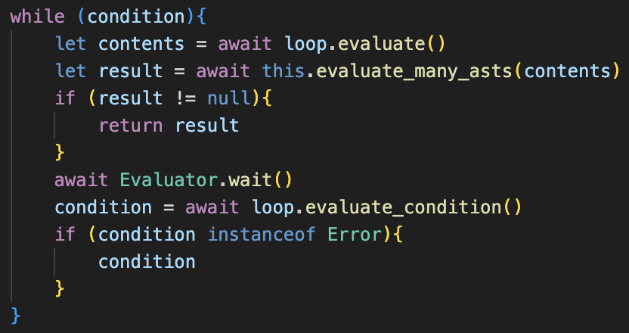Currently, when typing while True loop, the program will not print anything, and will just begin to lag and eventually crash, which is an issue.

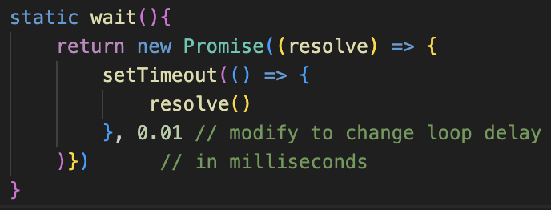The solution to this is to just make the Interpreter wait for a tiny amount of time on each iteration, in this case 0.01 ms.

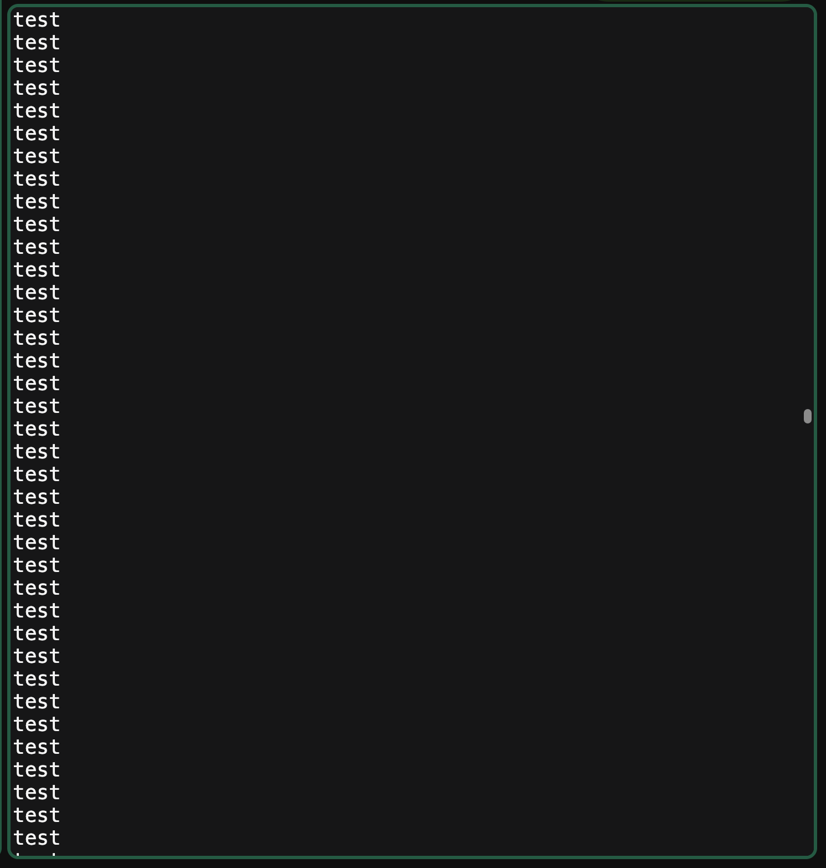I made this tiny so that it would barely impact the performance of the loop, and so the interpreter still executes quickly.

This small delay allows the interpreter to render the outputs and ensures that it will no longer crash as it slows the rate that it is iterating at.

However, I have two issues with this: there is no way to stop the program running without closing the webpage so it will just infinitely print with no halting. Additionally, the output will not scroll down to the latest output, so I’d like it to scroll down whenever something is printed so the user is not left behind.

Because I’d like to scroll to make it visible whenever any output is displayed, either a print, or an error message, or an input prompt, I am going to combine the printing code into a single function to make it more readable.

This is because the auto-scrolling requires an extra line so packaging them into a function avoids repetition.

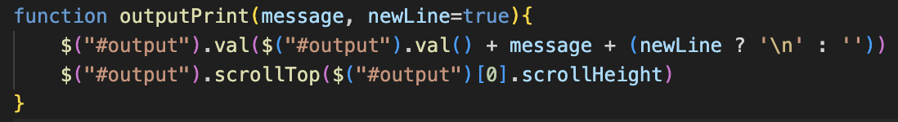The function is as shown and has an optional newLine parameter so that inputs can also use the function without moving to the next line.

The scrolling line is the second line and will automatically be run so the user can always see what was most recently printed, and not lose any outputs.

Then I replaced all the old print messages, with an example shown on the left from the Print class.

From here, it will automatically scroll so the user can see the latest additions.

### stop button

Now, I want a stop button so that the program can be aborted when running. I could use a separate button for this, however the Run button transforming into a stop button made the most sense.

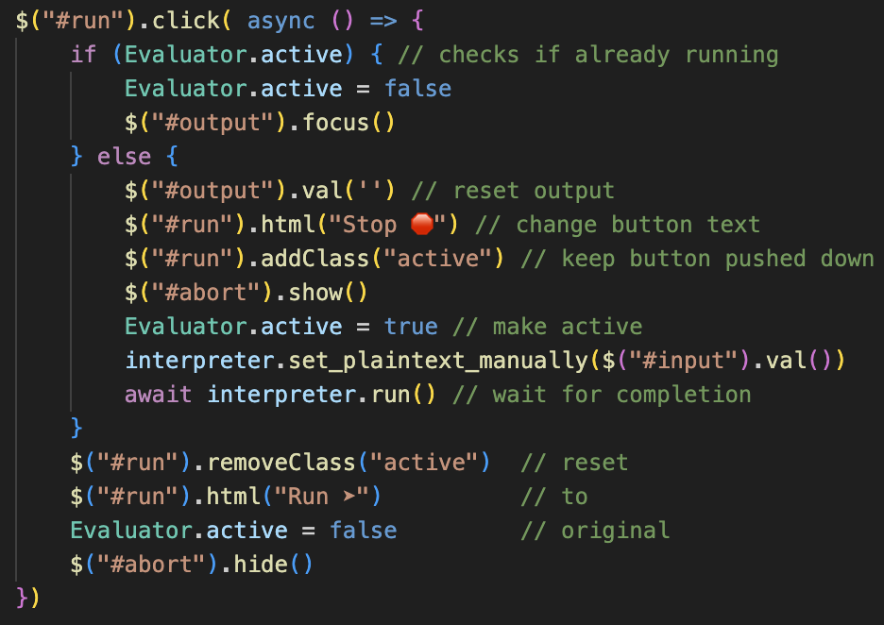This requires an extra check in the run function, so that if the program is currently active, it will set it so that it is no longer active, and then continue with the original final code: setting the run button back to its usual state. I also updated the new run code to change the button text to Stop, as well as updating the CSS to a red style.

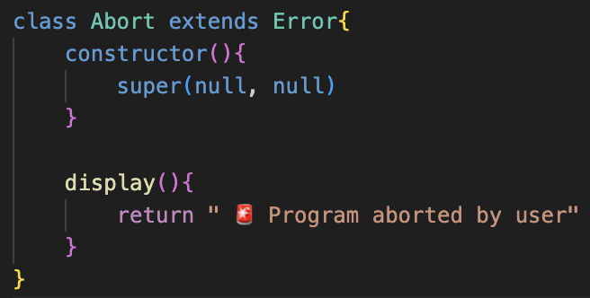I also added a new Abort class, which is a type of error which will only be used when stopping a program to run, so has no properties and has no arguments for the constructor.

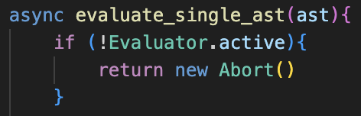Now, in evaluate_single_ast(), and inside the loop for evaluate_loop(), the program will constantly check if it is still active, and if it isn’t, it will return a new instance of Abort(), and because this is an error it will be passed all the way back to run(), and the program will halt.

I also must account for when the program is halted during an input:

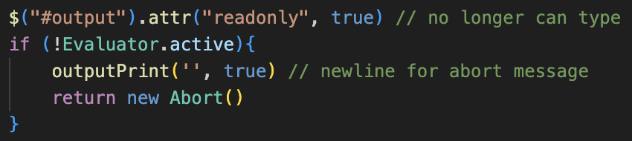Now, the loop when waiting for the enter key is also based on whether the program is active or not.

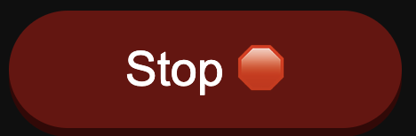So, when abort is clicked, it will exit the input loop, and this check will then return a new abort, after ensuring that a newline is printed to keep consistent formatting with the error messages.

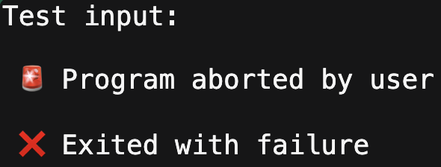So, after these changes, the run button will switch to the stop button which is shown on the left.

Then when clicked, the program will halt, and the following messages will be displayed, and the program will correctly abort.

I also updated the exiting messages slightly.

Now this section is complete, so while True and other infinite loops no longer crash the program, and the outputting is also a lot smoother and less jagged for the user.

# implementing a better text editor

When researching how to implement syntax highlighting in a <textarea> element, I found out that it was not possible to highlight only certain segments. The alternatives were using content-editable <div>s, but also suggestions to use pre-made packages to render a proper interface for you.

When researching these, a lot of them only allowed for syntax highlighting from a list of pre-existing languages, and I required one that allowed for more customisation for this language. When having a look, I found a package called codemirror.

The link for this plugin is at: <https://codemirror.net/>

Throughout I have also used a lot of documentation from the website to help with the setup. For any super relevant parts, I will link the specific pages, otherwise they are found in the documentation section, especially on the version 5 page as that is what I’ve used.

### using a custom lexer

There is additional plugin that can be used called Lezer, which can be integrated with the code mirror plugin, found at <https://lezer.codemirror.net/>

This allows the syntax of the parser to be written in detail, with a syntax very similar to Backus-Naur form. This would allow the parser to provide additional details, such as some basic error messages when not following the format, and additional features such as auto-completion and suggestions.

However, unlike the base code mirror, this feature required lots of other different imports, including package managers and lots of repositories which really convoluted the project. I spent a few days trying to get it to work, but after being faced with too many errors and adding loads of additional files to the project.

Therefore, I decided revert to the basic code mirror, which was annoying due to the time I put into it, but it is still possible to add syntax highlighting, but without the intelligent aspect.

## implementation

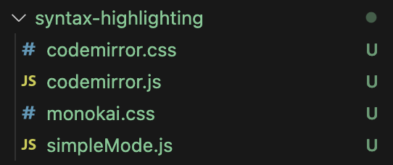The four files I’ve had to install are shown on the left.

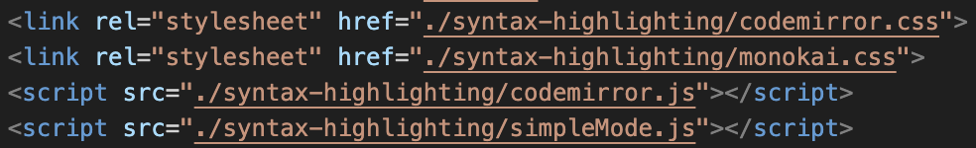These are linked at the top of my HTML file. This means that my main file will be able to access them, because they are referenced before it, so I can access my code in them.

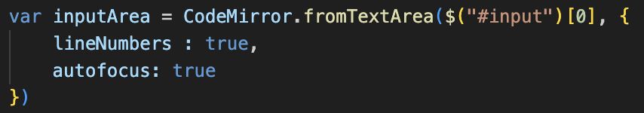The two code mirror files are the basic files needed to run the package, so I will explain them first before continuing to the others.

To set up the textarea, I use the .fromTextArea method for CodeMirror, passing my textarea and a set of parameters as additional options.

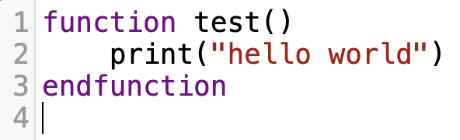Code mirror then automatically creates the window which can be typed into. This provides line numbers, which will be useful for corresponding with the error messages. There is also some basic syntax highlighting, however currently it is not specific to ERL so is not super useful.

The other benefits are the key binds, such as using tab for indentation, as well as shift tab for un-indenting will make the overall experience a lot better. However, now I need to customise it to become more specific to ERL for better features.

### customisation

Firstly, to get rid of the light mode, I found a repository which contained lots of themes which would better suit the style of the interpreter. This was at the repository: <https://github.com/FarhadG/code-mirror-themes>

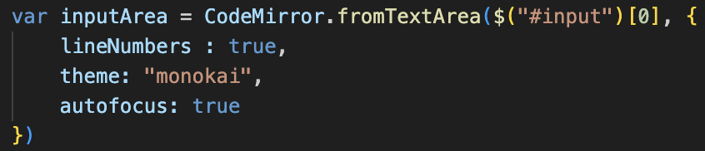I chose the “monokai” theme, and edited the CSS file slightly so that the background colours would match, and so that it would remain coherent with the rest of the user interface and not be drastically different.

I also edited the main code mirror file to change the styling of the main window slightly to ensure that it properly scales with the rest, as it does not inherit the textarea’s CSS completely.

Then, to get the highlighting to perfectly match ERL, I used the simple mode addon for code mirror, which allows the different tokens to be defined using a series of regular expressions, rather than defining a whole custom syntax in a grammar file like the more advanced version.

The documentation for the addon: <https://codemirror.net/5/demo/simplemode.html>  
The code for the addon: <https://codemirror.net/5/addon/mode/simple.js>

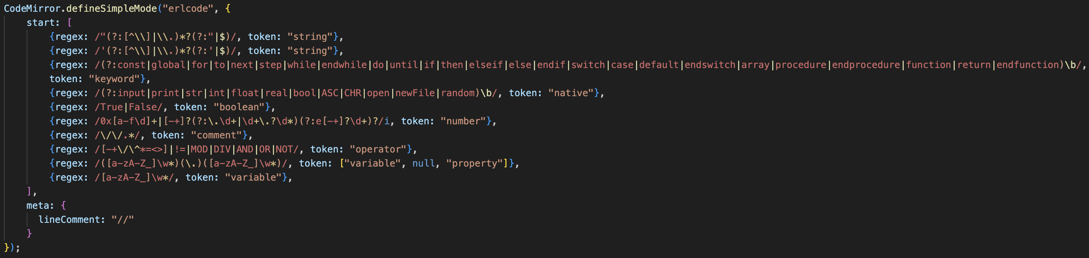I started by using the default template that the documentation provided for simple modes and modified it for my syntax. After modification, I ended up with:

The start section contains all the different regular expressions, with the highest priority at the top. The first two were in the example on the website and will account for any strings. I added two, one for using double quotations, and one for using single ones, so that both will be highlighted.

After this, I added checks for every single keyword, and every single native function in the program, so that they will be uniquely coloured. This also includes the True and False keywords for booleans.

I also kept the default regular expression for comments and operators, but expanded the operators to also include MOD, DIV, AND, OR and NOT as these are specific to ERL.

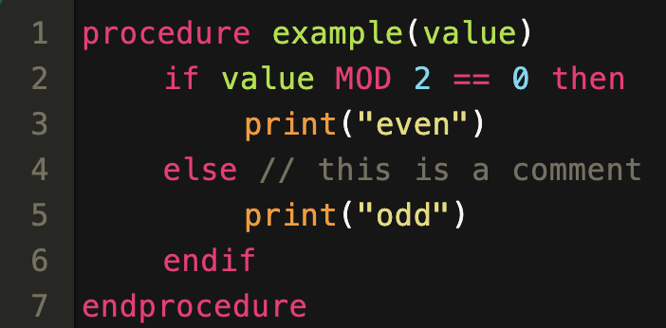I then wrote my own regular expression for variables because the default did not allow for the identifiers to begin with a capital letter. This is shown in the final line, and above it I added an additional check for properties, so that if a variable was followed by a dot and then another variable, the second one will be tagged as a property and then will be displayed differently.

I then changed the names of the styles in the theme css file to match with my token names that I wrote in the simple mode.

Now, as shown on the left, the ERL code will be correctly highlighted, which significantly increases the readability, and will make the interpreter a lot easier to use. This, although a simple change, was mentioned by both of my stakeholders to be important so should be very useful.

### auto indentation

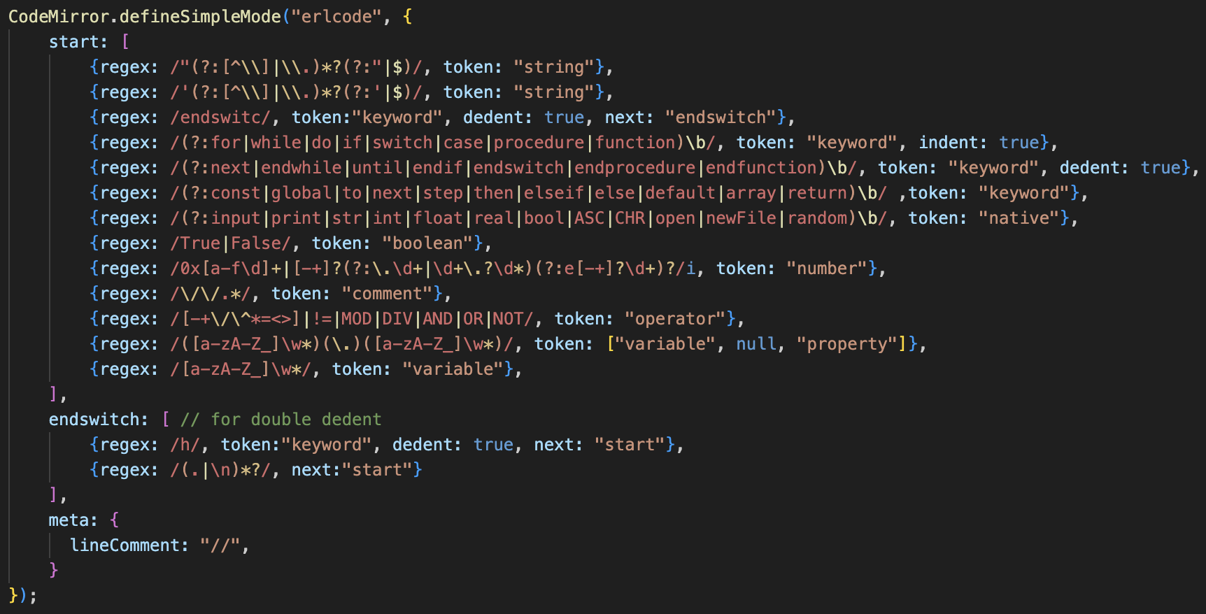I then updated the keywords by allow for auto-indentation.

This means that all opening keywords will cause indentation to occur, and any closing keywords will cause a de-dent, which means that it will be correctly structured.

This was very simple, except for the “endswitch” keyword. Because an indentation occurs on the “switch” keyword and the “case” keyword, endswitch needs to unindent twice, which is not easy to implement. My solution is that whenever “endswit” is detected, the mode will switch to a different set of regexes. If the next character is a “h”, then it will dedent again, and otherwise it will not and return to the start without creating a token. This means that the highlighting will still be correct, and because endswitch is now technically built of two tokens with two dedents, it will properly return to the original state.

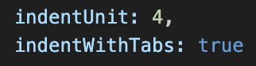Although not a perfect solution and slightly a workaround approach, it worked and there seems to be no alternative approach to allow for double dedents.

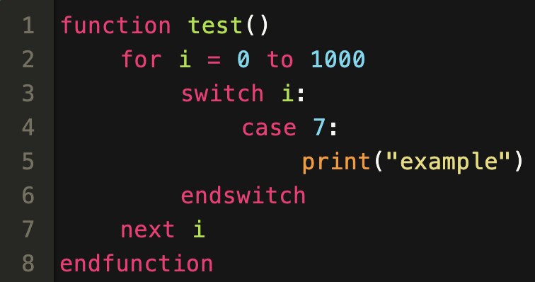Finally, I changed it so indentation is done by tabs, instead of spaces, so that they can easily be deleted without lots of backspaces being required for each space, and so that all sizing is consistent.

However, using consistent indentation is still unimportant, because the actual Lexer completely ignores any whitespace so it will not affect how the program runs, it is just completely visual.

The example on the left was completely indented by auto-indentation, without any input from the user, and it is very readable.

This is now all the features I want to include for the formatting of the input window.

## loop speed issues

Earlier, I changed it so that loops would wait on each iteration so that any outputs could be rendered. Although this did result in the printing being a lot smoother, it means that any programs that did not output, but still iterated, had significant speed decreases.

The main example of this was my binary Converted, which uses lots of iteration. This was only noticeable when a long sentence was passed into the input, and there was a considerable slow down.

My solution is to now ensure that after every print, the program waits for a short time to allow it to render. This therefore means that waits will not be required on every iteration in the main loop. Instead, I am going to make evaluate_loop() iterates a certain number of times before waiting. This will mean that the program will still not crash with while True loops, however because the waiting is not being done all the time the program will not experience any slowdowns that are not needed.

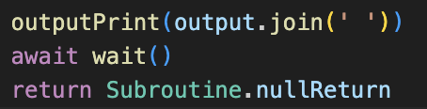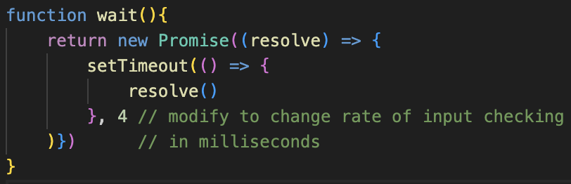To start, I moved the wait() function to be a global function, as I had already re-used it in both the Evaluator and Input. Also, I set the wait time to 4ms, as when researching I realised that it is the smallest time that setTimeout() supports. I changed the Input class so that it awaited this instead of its old static method.

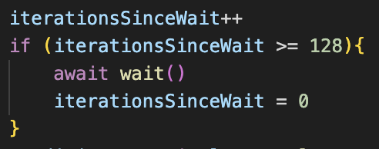Print was also now made to await wait() after changing the output, which should ensure that the outputs are continually updated.

evaluate_loop() now defined a variable called iterationsSinceWait at the start of the method. This will increment on each evaluation on the loop, and when it reaches 128, it will call wait(), and then reset the counter. I chose 128 as it seemed large enough to not affect most cases, but should stop infinite loops from crashing, but it can be tweaked later.

When running some test cases, this new approach has the best of both worlds: now the program no longer experiences delays with more computationally demanding inputs, but the output display is still continually maintained so the overall experience is a lot better.

# file management

This section of the Interface has not yet been designed; however, the main idea is that the output field can be interchanged between different files and they ca be edited and viewed.

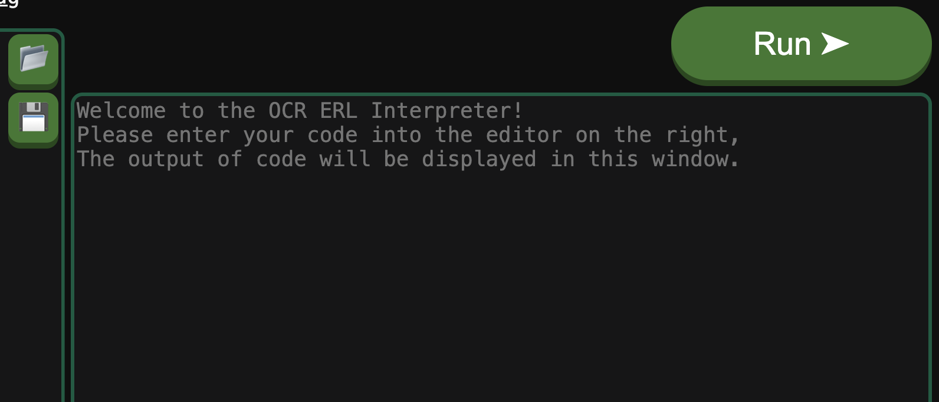

Main Console

myFile.txt

Add new File

Upload new File

File name

Rename

Save

Reset

Delete

File dropdown

My idea is on the left: having a label above the output to describe its current state: either as the output or editing a file.

Then, there will be a dropdown option to the left, allowing the user to navigate between the different states of the interpreter.

This means they can switch between different files, return to the output, or have the additional options of adding a new file, which will be blank, or uploading their own.

When the current mode is a file, additional buttons will be displayed, in a similar style to the upload and download buttons in the corner of the editor window. These are:

🡺 Rename button: as there is no way to change the file name in the editor  
🡺 Save: allowing the user to download the current state of the file to their local files  
🡺 Reset: resetting the file to the value before the previous run.  
🡺 Delete: deletes the file, so that it can no longer be used by the interpreter.

Additionally, this must update with the File Management instance, so that any changes to the file can be used by the interpreter. Also, the files should not be accessible when the program is running, as this could cause lots of issues with inputs() so we need to ensure the program cannot break.

Overall, this should be sufficient for files to be properly used with the interpreter, which then should wrap up all the features needed for the interface, except for some smaller, quality of life features which I will introduce afterwards.

## adding the dropdown

In order to get the dropdown to properly display, I used the following link to get the CSS and structure of my HTML so that it works: <https://www.w3schools.com/howto/howto_css_dropdown.asp>

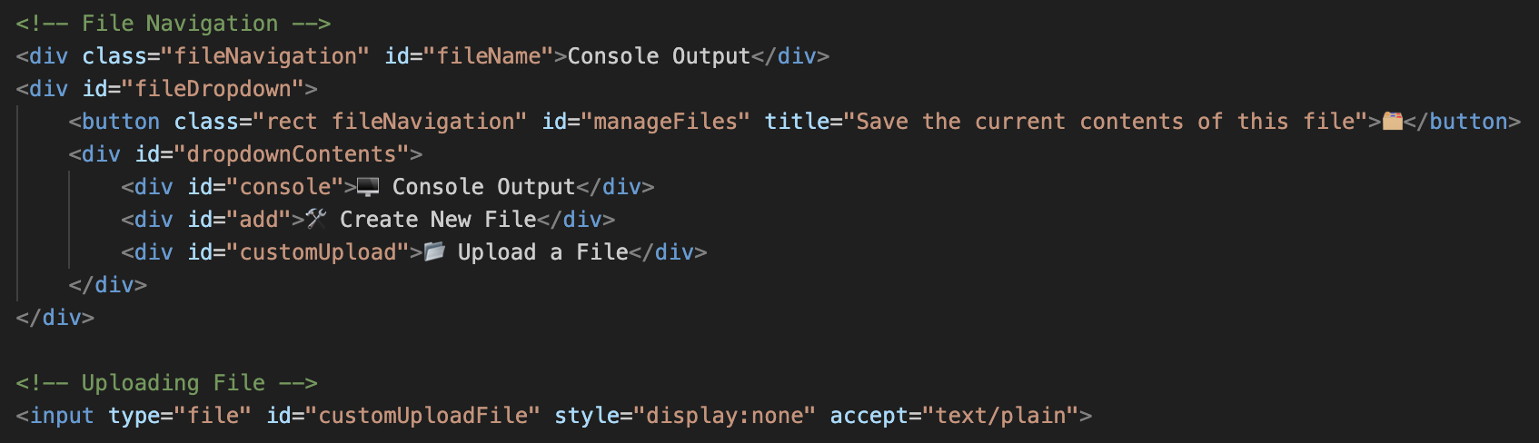Using this, I devised the layout on the left for my HTML file.

This includes the label for the current file, which will be set to display that it is in the Console by default when loading.

I also added the hover button for files, and 3 default items in the dropdown: for switching to the console, adding a new file, and uploading a file. I also added the input file type, which I will be implementing very similarly to the ERL upload, so it is required. I will not show the CSS, as it is purely styling, but it makes it so the dropdown is only showed when hovering over the file button.

### creating new files

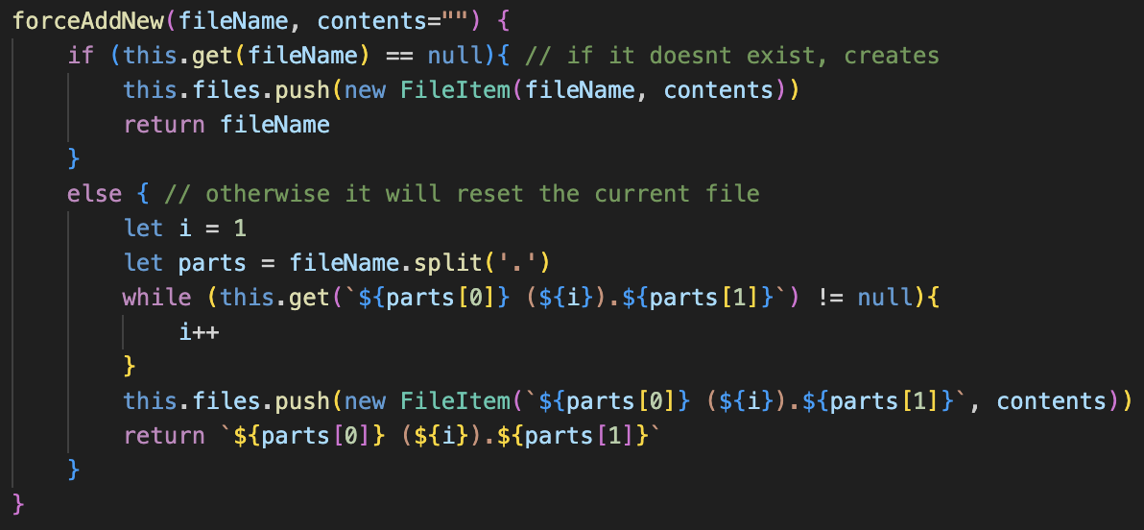Because I don’t want any files to be rejected due to matching names, I need a way for existing file names to be modified when created. My idea is very similar to a PC’s file management: and if a file already exists, it will rename the new one to include a (1) afterwards, or a (2) if needed, and so on.

For this, I am adding a forceAddNew() method to the FileStorage class. This is similar to addNew(), but instead of resetting a file if it exists, it will add brackets with a number, and iterate until an available name is found.

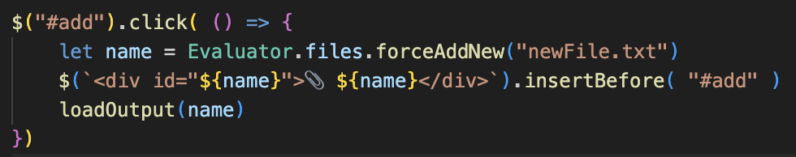It then creates the file, with an optional contents parameter, and will return the name that it used, as it may not have been the same as the name entered.

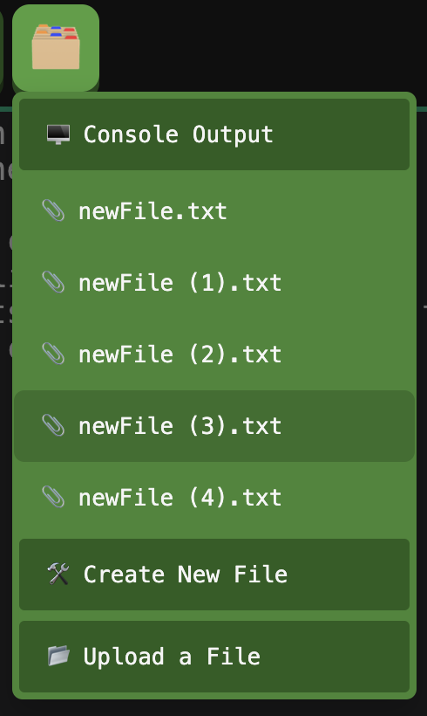I then added the event listener to add, which will call this forceAddNew on a default name, which is currently newFIle.txt, and I can potentially change this later when renaming is added.

Additionally, this method will create a new div in the dropdown, before the div for adding a new file so an order is maintained, with the corresponding name of the new file, and the ID will also match the tag, which will be important for when switching between files is needed. loadOutput() will also be called, which I have not yet fully implemented but will explain after this.

As shown on the left, a new file will be created on each click of Create New File, with none having matching names.

Also, the styling of the CSS can also be seen, and I feel like it is very clear, with the file that is being hovered over having the darker colour. From here, I need to allow the user to click on these different file names, so that they can be opened within the editor.

### switching between files

First, I added two global variables: one to store the contents of the output, so that it is remembered when not open.

Secondly, the currentFile variable will be a string representing what is currently open in the output window: either the name of the file or “output” for when the console is open.

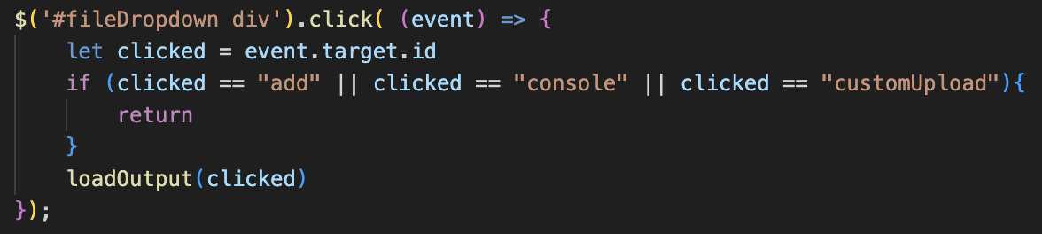loadOutput() will accept a string and will switch the output window to this string. This is why it was called in the add function, because whenever a new file is created it will be automatically opened. Before going into detail on how it will work, we need to be able to click on the different files to switch between them, so some detection is needed.

My solution is adding an event listener for when a div child of the dropdown is clicked, and it will set the clicked variable to the ID of the element that was clicked.

Earlier, I made it so that any file that was created would have its file name as an ID, so the ID that was clicked on was the file that must be loaded, so it is passed into loadOutput so that it is rendered. I also made it so that the “add”, “console” and “customUpload” clicks would be ignored, as they will all have their own individual event listeners as they function slightly differently.

### A screen shot of a computer program Description automatically generatedload output

The loadOutput function has two parts:

Firstly, it must save the old file. If it used to be an output, then it will update the savedOutput variable. If it was a file, it will call rewrite() on the file item that corresponds to the old name. That method just resets the contents and will write the value that is entered. Therefore, this will save the updated value of the file so it can be changed.

Secondly, it needs to load the new file. If it is becoming an output, then the outputs value will become the saved output. It will then change a lot of attributes: making it readonly, updating the placeholder, changing the file name to Console Output, and will hide any fileOptions (for when the additional buttons are added later).

If not, then the files contents will be loaded, and the opposite of these attributes will be loaded, setting the filename div to the name of the file for a more visual representation.

Finally, currentFile is updated, and the window is focused. I also added a check that if the new file is the same as the current, it will immediately exit the method.

### A black background with white text Description automatically generatedA close up of a computer screen Description automatically generatedtesting

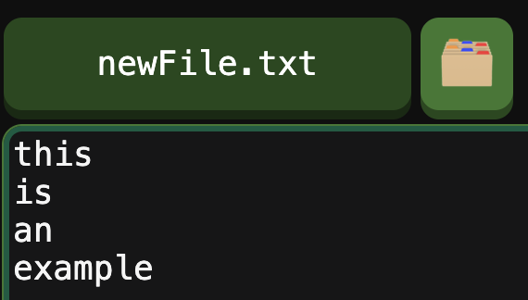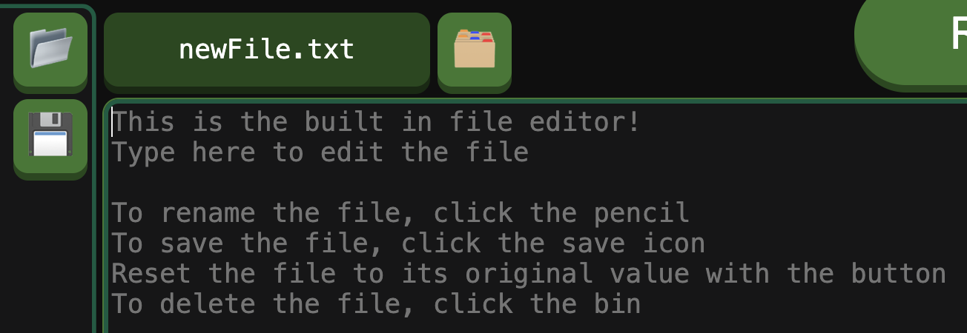Before running a test, I made it so clicking the console button and clicking the run button would load the main output, so that you can still switch back and it will always be on the output window when the program is running.

After adding this, you can see me navigating into the file editing window on the left. The proper name is displayed and I can enter text.

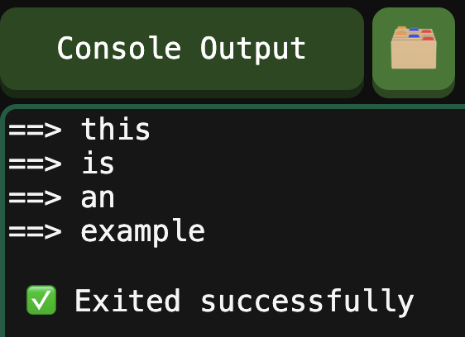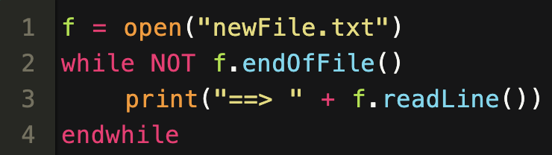I then entered some text into the file manually and wrote some ERL code which would output the file.

Now, when pressing run, it switches to the output, and the contents was correctly outputted.

This was very successful, as now the user can create and modify their own files in the interface, and it makes it a lot easier to work with files without having to create them in code.

### uploading files

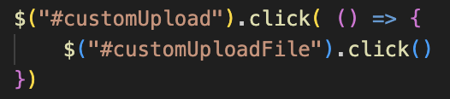The overall format for uploading non-ERL files is very similar to ERL files, except for the difference when the file is read.

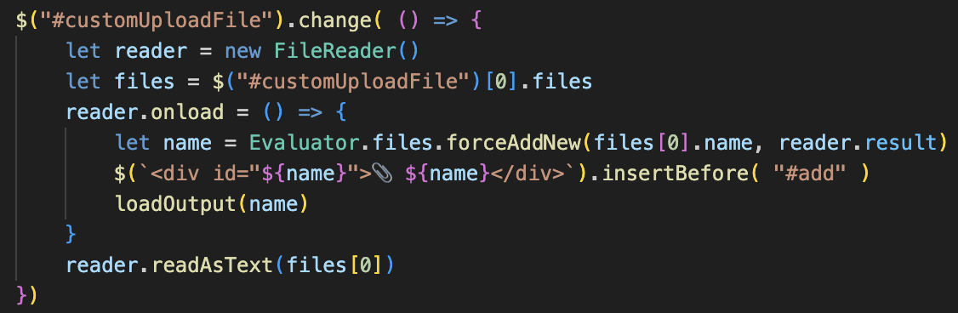Now, the name and contents of the file will be passed into forceAddNew, then the name of the file will be added to the dropdown, and the new file will be loaded into the output.

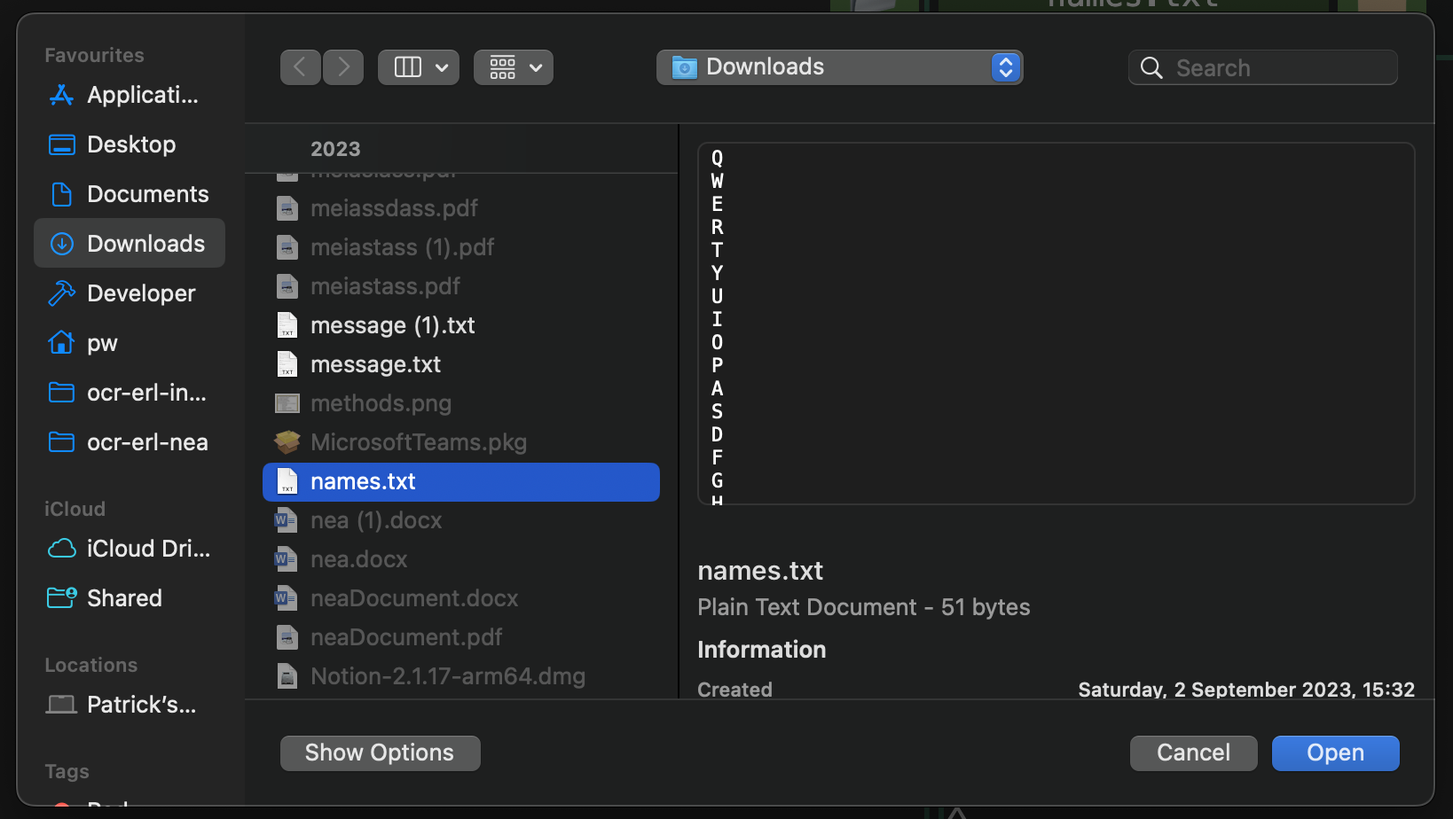Apart from this, the rest of the code is identical to the other upload, except for the element IDs.

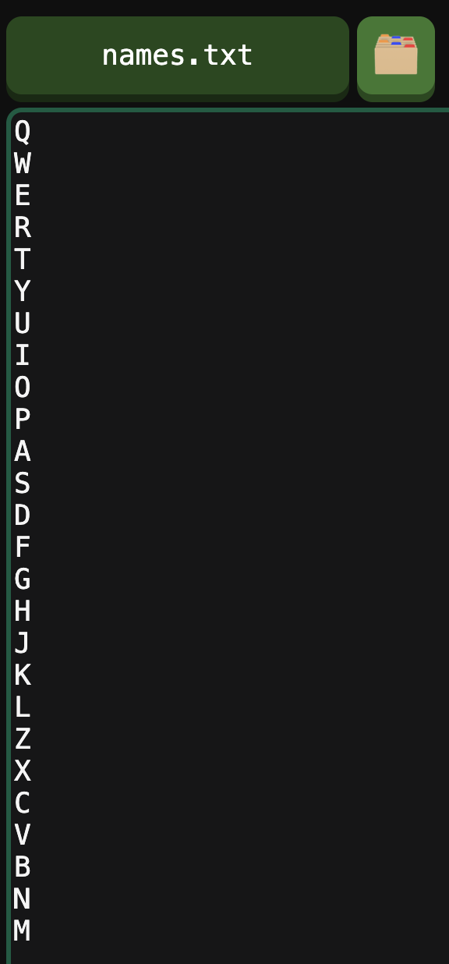Now, clicking the button opens the local file system, where I found a text file which was on my downloads and opened it, and it was correctly loaded into the interpreter, with the correct name being displayed, ready to be used by the interpreter in some programs which can be given by a teacher.

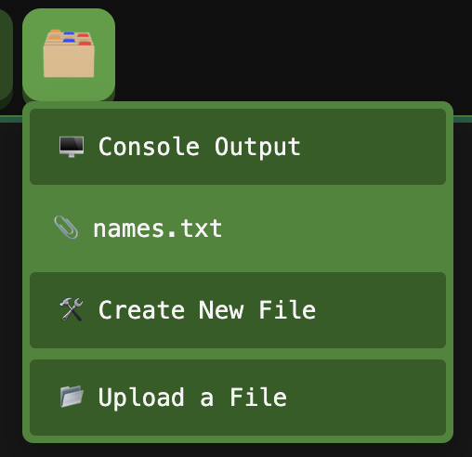The only remaining issue is that currently, the user can switch to a file when the program is running, and the program will write to the file instead of the output.

I could allow this, and just make sure it writes to the stored output variable when running, however this could be very confusing when inputs are required, so I am going to make it so the user is locked into the console window when the program is running.

### locking the output window

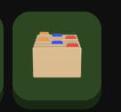My idea for this is to use the same active class as the run button, so that whenever the program is running, the dropdown and button will have the active class. Therefore, I can update the CSS so that, if it has the active class, it will not open the dropdown. I also updated some of the styling.

Now when active, the button will be deactivated, so the menu cannot be opened and the user will no longer be able to enter the file editing mode, fixing the issue.

## the file options

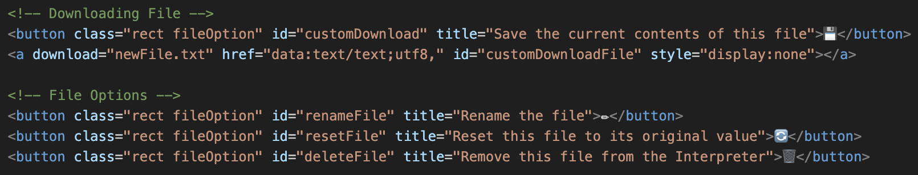Now I have added buttons for the 4 file options, as laid out in the plan. This also include the anchor for the download, as I will use the same method as for downloading ERL.

Additionally, when implementing displayOutput earlier, I made it so these buttons would be hidden when in the console, so they will only be able to be pressed when a file is open. Now, I need to add the functions for each of the presses.

### A computer screen shot of a program code Description automatically generatedrenaming

For renaming files, I’d like as few rejections as possible, so I would like to implement the same system as adding new files, so that it will be renamed with a bracket containing a number to make it unique.

For this, I made getNewName() a generic method to get the available name, and then forceAddNew() and the new rename() method will both accept this.

Rename() accepts the old name of the file, and its new name. It will change the name of the old file to the available new one, and then return that name.

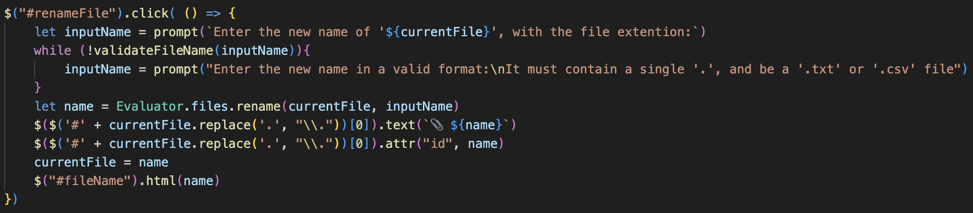Therefore, when the rename button is clicked, it will rename the file to the input, and then update the UI to reflect this: updating the dropdown’s text and ID, as well as the file name field.

I had lots of issues with jQuery in this section, due to the full stops in my IDs, as well as other errors with concatenation.

After some research, I replaced all the full stops to include a backslash, which fixed the issue as they were now treated as actual characters by jQuery.

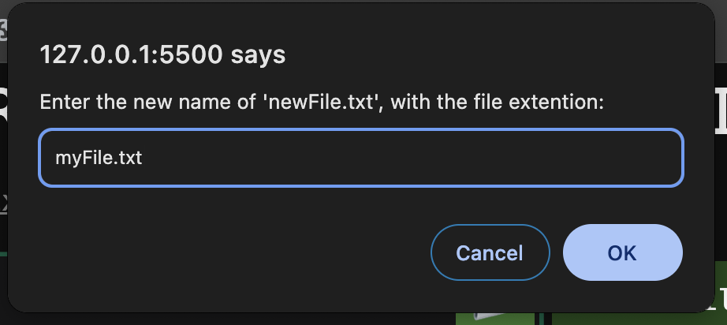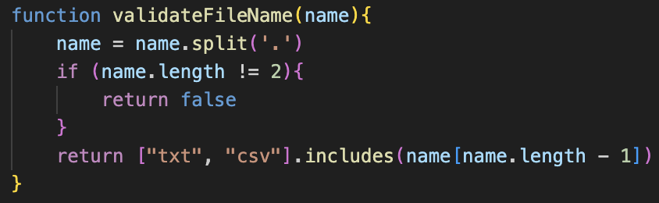validateFileName() is the method to ensure that the input is valid, so only contains a single full stop, and is a text file or comma separated values file, as I do not want users creating any different files, although this can be changed in the future if needed.

Now when clicking on rename, the prompt window will now appear. I could have implemented a custom input, but because it is a small feature, I felt that it was not needed.

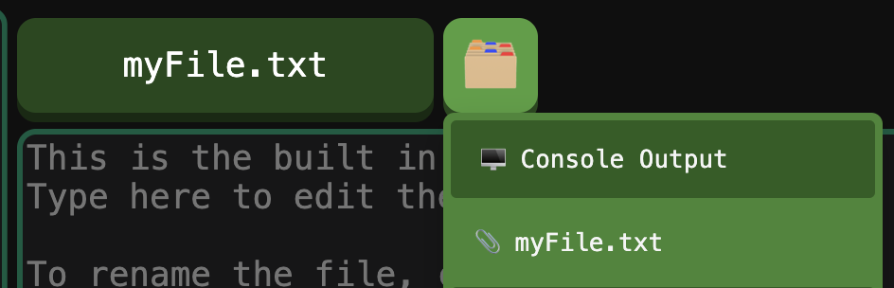After pressing enter, the file will then be renamed, updating in the interface as shown in the screenshot.

This new file can still be accessed by the interpreter, as it has also been updated in the file system.

This concludes the renaming section, as it now completely functions as intended.

### downloading

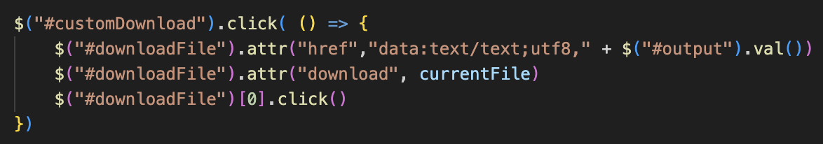I realised I could reuse the same anchor as my old download, so I removed the second anchor and re-used the same one for the file download. Now when the button is clicked, the current contents of the output window will be the contents, as this will reflect the currently opened file. Then, the currentFile variable will hold the name, so this can be the file name.

My exact code is shown on the left.

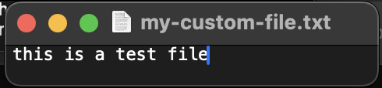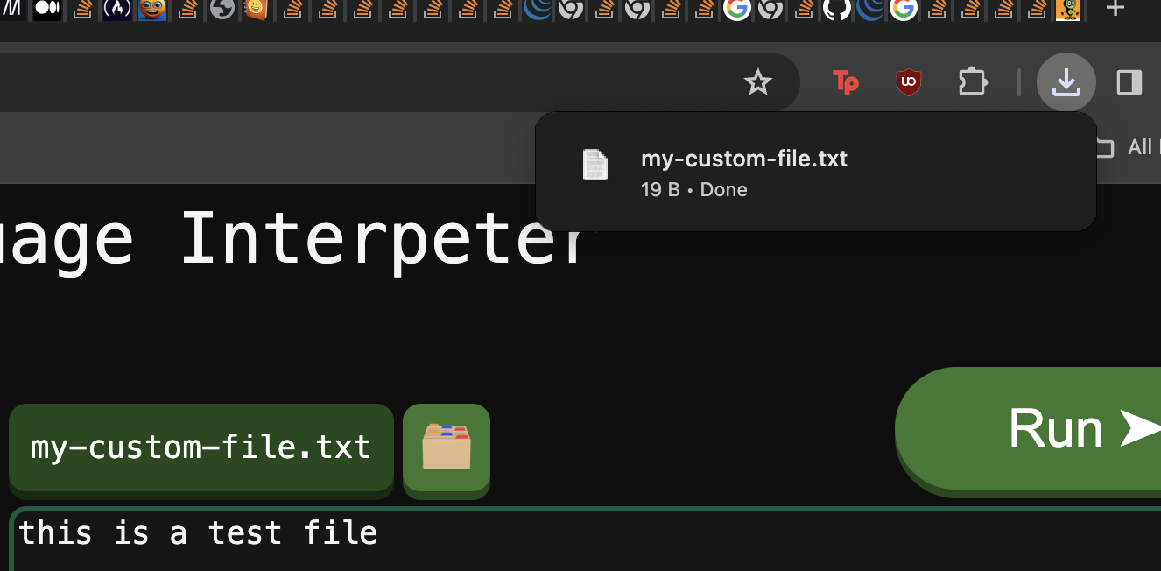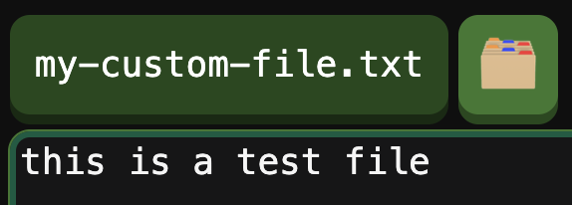The test case shows this working in practice. And, because using files in the interpreter will update the output, this allows for files to be created and downloaded successfully.

### creating files in code

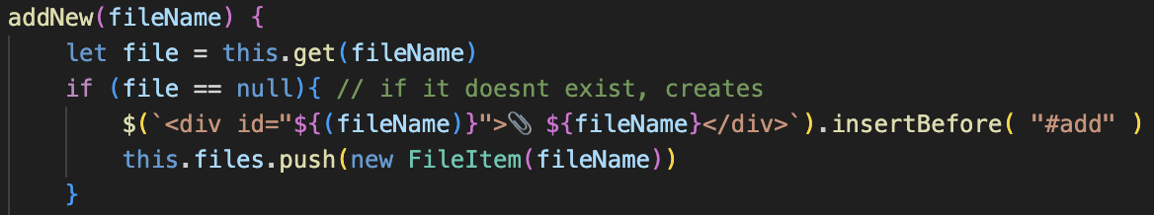Currently, creating any files by code will not be reflected in the interface.

To fix this, I added a line in addNew(), so that if a file that does not exist is created, a div will be added with its name.

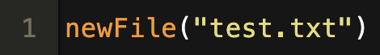Note that, addNew will override any existing files, because that is how it operates. So, if a file already exists, it will not create another with a different name, but will reset its contents. Therefore, if it needs to reset the contents, it will not create a new tag as one will already exist.

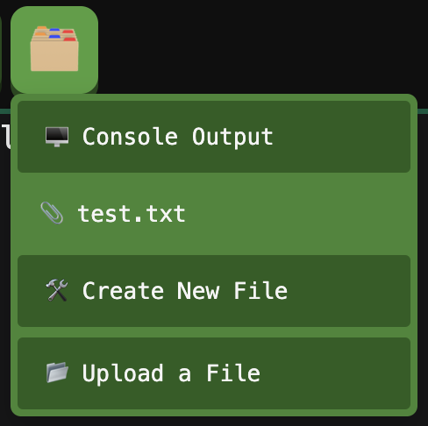As shown on the left, this functions as anticipated, and the file will now be able to be accessed to make sure the program has correctly written to it.

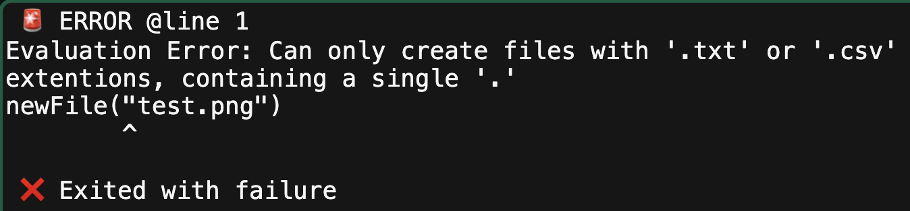I also used the same validateFileName method in the NewFile class(), to ensure that no illegal file names would be created, as shown.

### resetting files

The reason I would like to add this feature is so that, if a student is provided a file that they need to make a program interact with, and their code does not work as intended and breaks the file, then they will be able to reset the file to its value before being ran so that they do not have to reupload it on every attempt.

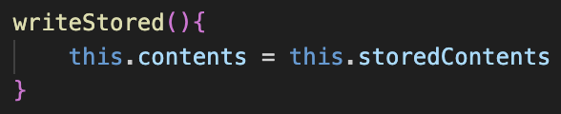Now, FileItem will have an additional property called storedContents, which will be a string.

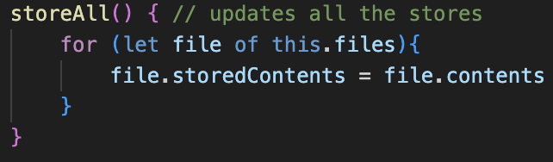They will also have a writeStored() method, which will update their contents to be their stored version.

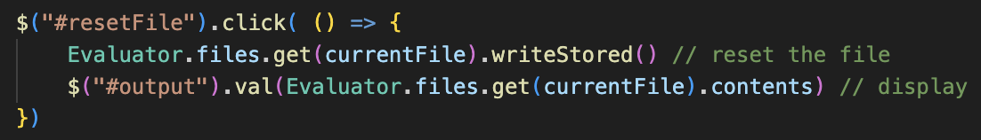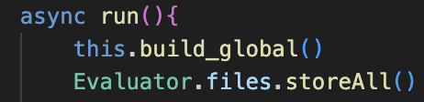Additionally, the FileStorage will now have a store All() method, which will set every single file’s storedContents to its current contents, which will be called on each run().

Now, when the button is clicked, it will reset the file, and will display the value: which resets the file to its prior value.

This is hard to show in screenshots, so I will show it later in the example video.

### deleting files

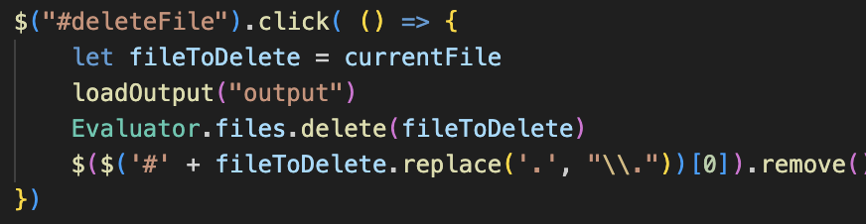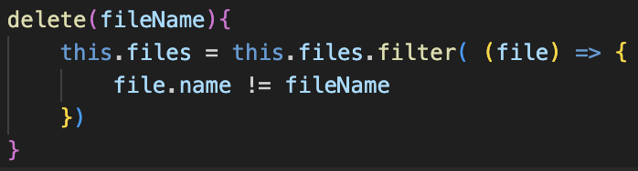FileStorage now has an additional method called delete(), which will filter its files array, removing any files with the argument.

So, when the button is clicked, the current file is passed to this.

This will remove the file from the storage, as well as removing the div from the dropdown.

The output must be loaded before this is done, as otherwise there will be issues with file names not existing, as I had errors when loading last.

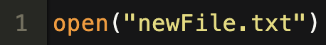Again, it is hard to demonstrate with screenshots, but pressing delete will remove the file, and when attempting to use the program will return an error, which is correct.